**BLESSCO DISHES**

**THAT WILL BLOW YOUR TASTE**

**First Published 2023**

All right reserved. No part of the book may be used, reproduced, stored in a retrieved system or transmitted in any form or by any means, electronic, mechanicals, photocopying, recording or otherwise without prior permission of the Author

@Blessing Sunday 2023

Publish by

**ACKNOWLEGEMENT**

I am grateful to god for his grace in making this book a success. Thanks goes to my client who are always asking for knowledge about my cooking

1 appreciate my lecturer, Mr Lawrence Ubah for giving me the opportunity to put my cooking experience into writing. And to my mother (Mrs) Victoria Sunday who has always b there to teach and educate me more on my cooking. Thank you.

**CONTENT**

1 Introduction

2 Jollof rice

3 Garri (Eba)

4 Pounded yam

5 melon soup (Egusi)

6 Moi moi

7 porridge yam

8 Edikang Ikong soup

**CHAPTER ONE**

**INTRODUCTION**

Nigerian cuisine is rich with unique recipes and in the way the food is prepared. For examples, it’s a well- known fact that jollof rice tastes better as a leftover.

Unfortunately, few people in the western world have experienced authentic Nigerian food. Food in Nigeria is aumatic, delicious, and always made straight from the heart.

A large share of every Nigeria food is enveloped with vegetables herbs, and spices with groundnut oil or palm oil making the food highly scented and spicy.

Nigerian food can still be differentiated from other west African meals due to its deeply rooted flavored sauces and soups. Starchy foods like yam, cassava, plantain, rice and bean figure prominently in the Nigerian diet.

They’re often consumed with a wide array of hearty soups and stews made with different types of meats and vegetables.

**CHAPTER ONE:**

**Jollof Rice**

This is one of the most iconic foods in Nigeria and is eaten in every part of the country. You may wonder why it’s so highly rated, and it will shock you to known that it is simply rice prepared with tomato, onion pepper, and some other species. The secret lies with the species

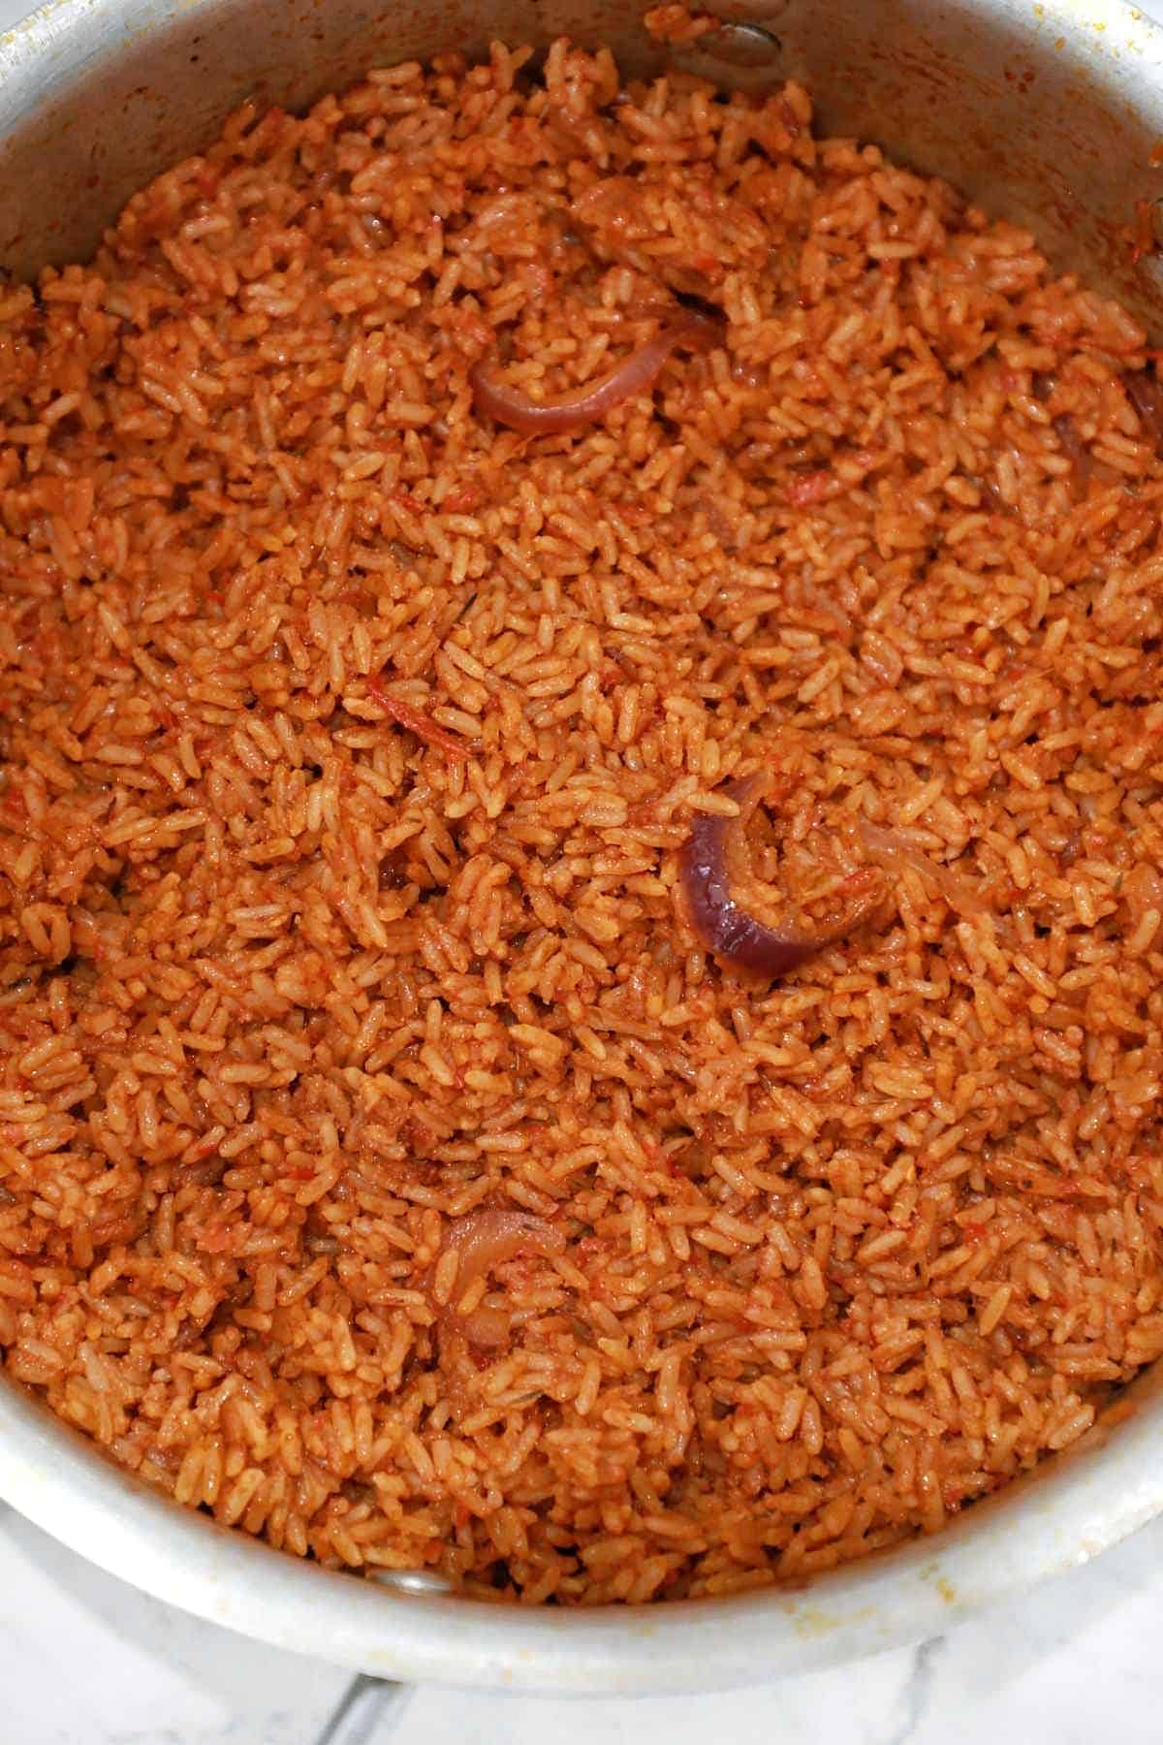

**INGREDIENT FOR PREPARING JOLLOF RICE**

* Oil
* Pepper (dry)
* Tomato paste
* Curry powder
* Dried thyme
* Bay leaves
* Rice
* Salt
* Fresh tomato
* Fresh pepper
* Tatashi
* Maggi

**HOW TO MAKE JOLLOF RICE**

1. Blend the fresh pepper and tomatoes, tatashi together. Chop your onions and keep them aside
2. Put your rice into a bowl and soak with hot water. Allow to soak for 10-15 minutes. Then wash with warm water and keep aside or parboil your rice and wash. This is important as you will get rid of excess starch in the rice.
3. Heat up your oil
4. Put your chopped onions and allow them to fry. Be sure not to burn the onions in the process.
5. Add and fry your blended ingredient. Allow them to fry until you get rid of the sour taste (about 10-15 minutes).
6. Add your maggi, curry, thyme and salt. Mix it all together. Be careful with your maggi as you don’t want it to salty ( 2maggi cubes for a cup of rice). Add your stock or eater, and mix too.
7. Pour you rice into the pot and mix together. Make sure it is covered in the tomato sauce
8. Cook on low medium heat. Check your rice after at least 10 minutes, using a wooder spatula to drip into the rice this help with getheing the sauce to get the bottom of the pot so that it does not start burning when the rice is not cooked
9. Cook until soft. Do not over cook your rice or get your rice too soggy. When rice is soft, lower the heat add the bay leave and allow to simmer so the water will get completely.
10. Serve the rice. Serve with fried plantain and your choice of meat, if desired.

**CHAPTER TWO**

**GARRI (EBA)**

This is undoubtedly the most popular staple food eaten in Nigeria. It is consumed in the majority of housed irrespective of region or ethnicity. Garri consist of cassava flour combined with hot water. This is first harvested, peeled, washed and grind. It is then drained of water some starch, and hydrogencyanic acid before it is sieved and friend in a hot pan. The result of this process is called garri.

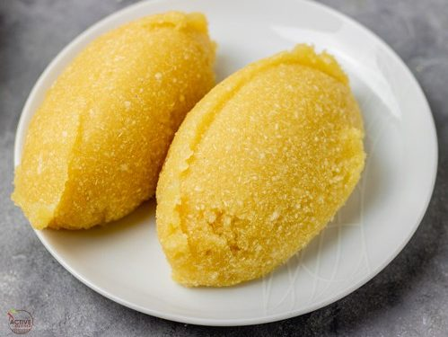

**INGREDIENT FOR GARRI**

* Water
* Garri

**HOW TO MAKE GARRI**

1. Bring the water to a boil in a large pot
2. Sprinkle in the garri, and cook, stirring constantly, until it becomes a paste similar to mashed potato consistency.
3. It can be eaten with any Nigeria soup, such as Egusi soup, Okoro soup Banga soup, Afang soup etc.

**CHAPTER THREE**

**POUNDED YAM**

This is a very soften food served in several Nigeria homes and restaurants it can be enjoyed with various soups such as ogbono, egusi, vegetable and Afang soups.

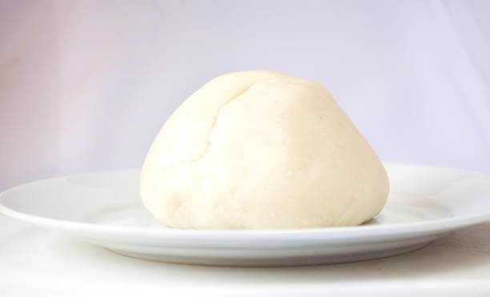

**HOW TO MAKE POUNDED YAM**

1. Peel the skins off the yam and slice them into about ½ inch thickness
2. Rinse and place the yams in a pot and add enough water to the level of the yams
3. Cover and cook the yams for about 30 minutes, chedang every 10 minutes or there about until the yams are tork tender
4. Pound into a dough like consistency until its completely smooth with no yam chunks left.
5. The amount of water you will need to boil the yam will vary depending on how dry the yam is
6. Pounding, you will need more water for the dry yam and less water for the less dry yams
7. Serve with your favorite soup.

**CHAPTER FOUR**

**MELON SOUP (EGUSI)**

This is one of the most popular soups in Nigeria, especially during celebrations when it’s prepared in many household, its unique texture and flutfiness are just two of the qualities that make this soup as special.

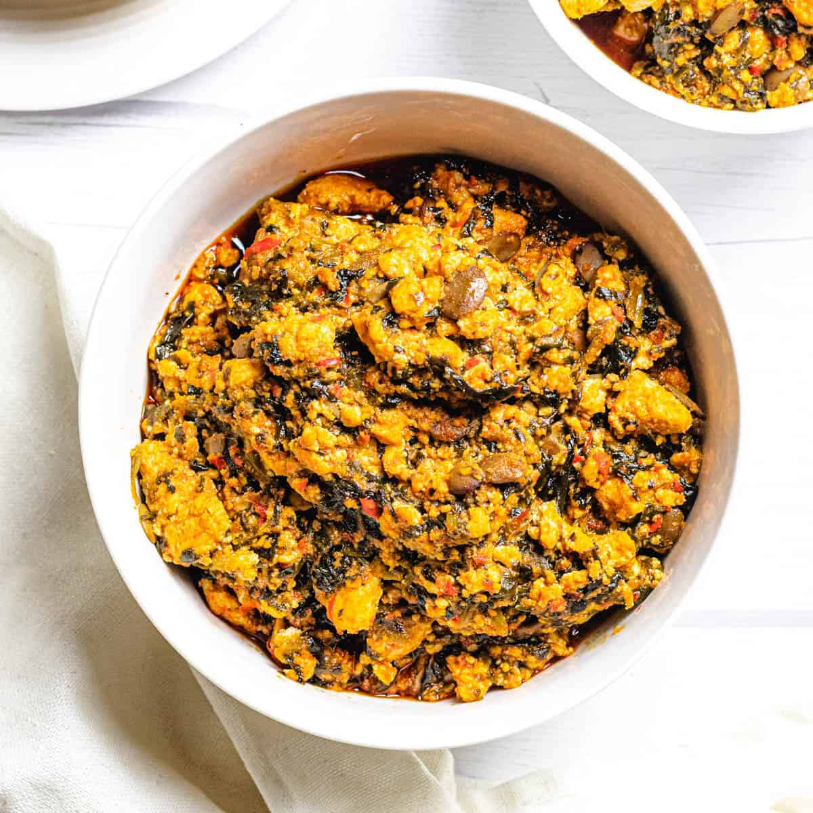

**INGREDIENTS**

1. Ground Melon
2. Beef
3. Stock-fish
4. Crayfish
5. Fish
6. Seasoning cubes
7. Onions
8. Pepper
9. Palm oil
10. Vegetable

It can be cooked in different method which is frying Boiling method

**HOW TO PREPARE EGUSI SOUP**

1. Add ground melon to a bowel; add about a cup of water and mix to form a paste then set aside. wash and chop the vegetable
2. Place a big pan on medium heat add palm oil and heat for about 3 minutes add the chopped onions
3. Add pepper mix stirred to combine.
4. Add the Egusi paste in a bits to pepper, reduce the, do not stir the soup. The Egusi would be lumpy at this point.
5. Remove the lid, and gently stir the soup. The Egusi would be lumpy at this point.
6. Add smoked fish, ground crayfish beef stock and stir to combine.
7. Add the waterleaf
8. Stir and put a lid on the pot and allow cook for 7-10 minutes, till the leaves wilt.
9. Add the bitter leaf, leave the lid while the cooking finishes for another 5-10 minutes
10. Stir, check seasoning and Adjust accordingly

Your soup is ready served with Eba or pounded yam.

**CHAPTER FIVE**

**MOI MOI (BEAN CAKE)**

Moi Moi is one of Nigeria’s mouth watering recipes that will blow your taste buds. Just like Akara, made from processed beans, but the difference is that it is boiled instead of fried.

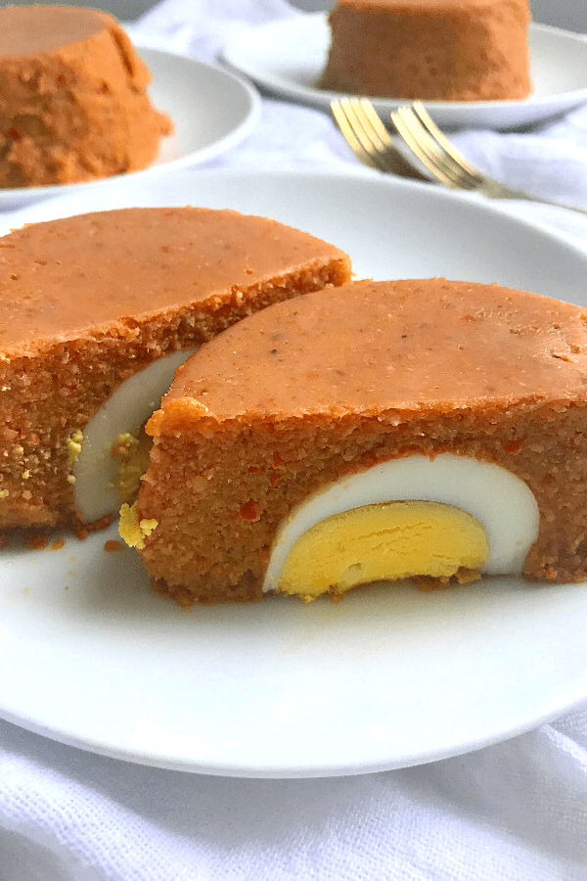

**INGREDIENTS FOR MOI MOI**

* Fish
* Cooked egg (optional)
* Vegetables oil
* Seasoning cubes
* Salt
* Onions
* Pepper
* Crayfish
* Beans

**HOW TO PREPARE MOI MOI**

1. Put your beans in a bowl. Sprinkle a handful of water and start squeezing with yours
2. You can add a little more water but don’t allow it to soak, continue squeezing until it shades off the outers coat, you had done it for 3 minutes
3. When the have shaded off their outer- coat, add enough water to fill the bowl
4. Wash the beans to remove the outer coat, keep squeezing, washing and sieving till you are left with the white beans then you can prepare for the grinding part.
5. Parboil the fish pick out from the water then pieces the fish
6. Add onions, crafish pepper into a small clean bowl then blend all together
7. Inside the bowl add the fish
8. Pour in the oil into fish grind beans add seasoning cubes, the fish water salt to taste. Stire and taste the entire mixture
9. For this final process, you need a moi-moi paste into steam it. Some people use banana leaves, foil or mio moi pouches
10. Cook for about 30-35 minutes until the moi-moi is ready (and you will know that it is ready by opening one of them and outing through. It will befirm and the color will have intensified a bit). If still a doubt, cook the moi moi to the maximum cooking time
11. Serve on its own or with rice or Nigerian stew

**CHAPTER SIX**

**PORRIAGE YAM**

Yam porridge is another delicious Nigerian yam dish cook in a well-seasoned pepper mix until soft and fluffy with some yam chunks. It is very quick and easy to make it makes a perfect dinner or lunch and it is also a pasty favorite

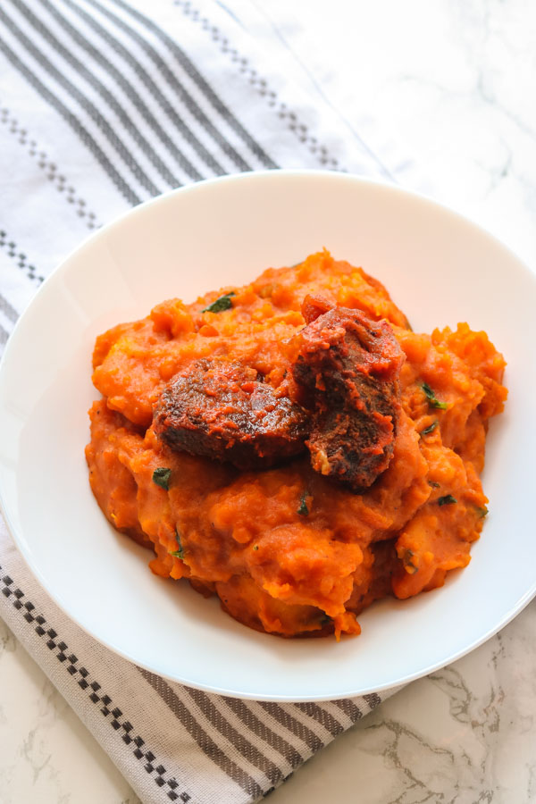

**INGREDIENTS**

Yam

Fresh pepper

Onions

Crayfish

Fish (roasted) you can use bonga fish maggi cube

Salt cube

Salt

Singer and garlic (optional)

Ugu leaf (slice)

Palm oil

**PROCEDURE FOR COOKING YAM PORRIAGE**

Step 1 , wash your fresh pepper and onions and your ginger and garlic clean your crayfish then add all to your blender add a little water and grind after grinding pour pot in a bowl and keep aside.

STEP 2, wash and slice your leaf and also anvdebone your fish and keep aside.

STEP 3, Peel off the slun of the yam and slice into small piece then wash and add to your pot, add salt and level your water with your yam and cook, cook to done then bring your pot of yam down.

Step 4 place your frying pan on the heat and add your palm oil allows to heat a little then add your blended mixture, then add your roasted fish, add maggi cube and little salt then fry for 3mins, after frying your sauce pour the source to your white yam and stir put back the pot of yam to the fire you can little water to thick and add your vegetable immediately stir all together and cook for 2mins and bring down ready to eat your delicious porridge yam serve with chill juice drink.

**CHAPTER SEVEN**

**AFANG SOUP**

Afang soup, made by the Efik and Ibibio people that live mostly in the coastal states of cross rivers and Akwa Ibom, is a stew made with Afang leaves and another common green leafy vegetable locally called waterleaf.

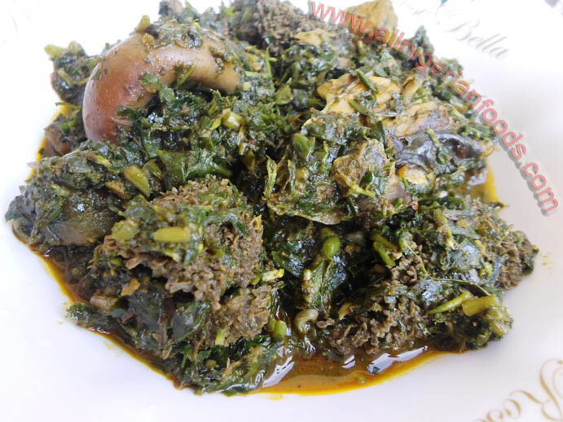

**INGREDIENTS**

Waterleaf

Afang leaves

Goat leaves

Snail (optional)

Oil pepper

Fish salt

Crayfish

Periwinkle (optional)

Stockfish head

Maggi seasoning

**PROCEDURE FOR AFANG SOUP**

1. Slice and grind the Afang leave
2. Season the meat with salt maggi
3. Slice the water leaves and set aside in a sieve so excess water will drain away
4. Wash the stock fish, driedhand add them to the cooking meat, let them cook till they are soft and the pot is almost dry
5. Add palm oil, crayfish and stir all together. Add one seasoning cube, ground pepper snail and salt to taste. Allow cooking for 3-5 minutes.
6. Add the water leaves, allow to simmer for 6 minutes while you stir continuously
7. Add the grind Afang leave stir all together, cover the pot and allow another 5 minutes, stirring every 2 minutes
8. And you done with a devious Afang soup

Serve with Eba, Fufu or pounded yam.

