**A**

**TECHNICAL REPORT**

**ON**

**URBAN RENEWAL OF IKOT EKPENE URBAN AREA**

**WRITTEN BY**

**IBANGA, CHRISTIANA EDET**

**AKP/ENV/ESM/ND2020/00559**

**COURSE TITLE: URBAN AND REGIONAL PLANNING**

**COURSE CODE: URP 111**

**SUBMITTED TO**

**COURSE LECTURERS**

**TPL. DR. KOFFI AYADU**

**MR. PAUL**

**DEPARTMENT OF ESTATE MANAGEMENT AND VALUATION**

**AKWA IBOM STATE POLYTECHNIC**

**IKOT OSURUA, IKOT EKPENE**

**JULY, 2022**

**CHAPTER ONE**

**INTRODUCTION**

Urban renewal is characterized by changes in physical structure, urban tissue, and the action of economic and social forces. As the city expands, competition for better locations occurs. In addition to this situation, regulations of land use and occupation contribute to the occurrence of different population densities.

Urban renewal is described as an interventionist activity to transform an urban area by improving its built environment and infrastructure, thereby enhancing the quality of life and provision of social services. It also improves economic conditions and employment opportunities, social and economic characteristics, and the advancement of environmental and ecological conditions as well. Urban renewal is a set of policies and planning practices that address urban problems through government-led redevelopment.

The urban renewal strategy focused on local community participation has demonstrated a positive effect on local realities. The market cannot adequately address the demands of renewal solely through its priorities. In this sense, one of the most widespread criticisms concerns to its failure to adequately meet a range of social needs, such as providing land for socially desirable uses, but not profitable, and serving economically vulnerable social groups

**AIM**

The aim of this field survey was to observed the state of the surveyed area in order to ascertain if there is need for urban renewal intervention.

* To provide for adequate expansion of the existing social facilities and establishment of new ones where needs arises.
* To minimize waste in construction, maintenance and controls of utilities and infrastructures through efficient land use.
* To arrange the existing land use in order to have a compatible and effective land use system.

**SIGNIFICANCE**

This study will be of importance to the government and the town planning committee and other appropriate agency as the basis for consideration and decision making.

This study will also be of benefit to the students as source of information for comparison and reference purpose.

**SCOPE**

The study area covers Umuaiha road, Nwa-eyen road, Chubb road and Alderton road in Ikot Ekpene Local Government Area.

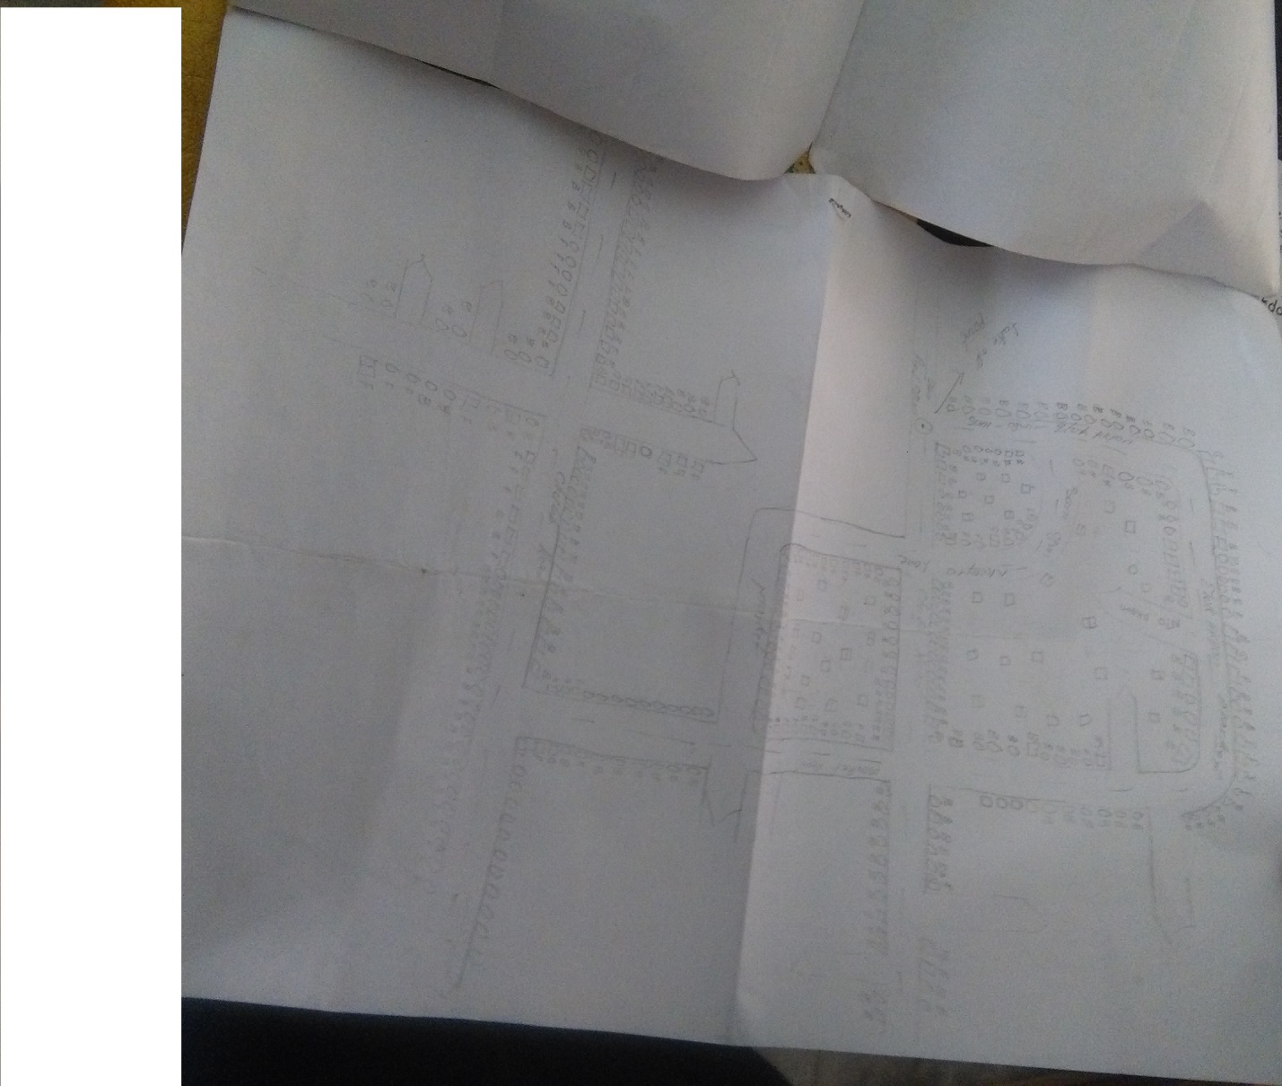

**LIMITATION**

The limitation encountered during the course of the survey were the busy state of the roads, the incessant movement by passers-by which disrupted concentration and lead to increase in more time spent during the survey.

**NEED FOR URBAN RENEWAL**

* Enhance housing affordability – Brings key workers closer proximity to employment opportunities
* Drives urban productivity E.g.: Creating mixed use development projects in CBD – Creating regional hubs just outside of city limits to reduce residential and commercial pressure on inner city area.
* Creates employment opportunities
* Attracts increased investments – Intensifying use of land – Densification of area can create new market for business

**CHAPTER TWO**

**STUDY AREA**

The study areas (Umaiha, Nwa-eye, Chubb and Alderton) lies between latitude 5011` longitude 7011` in other words, the study area is in Ikot Ekpene Local Government Area, Akwa Ibom State. Nigeria.

**MAP OF NIGERIA**

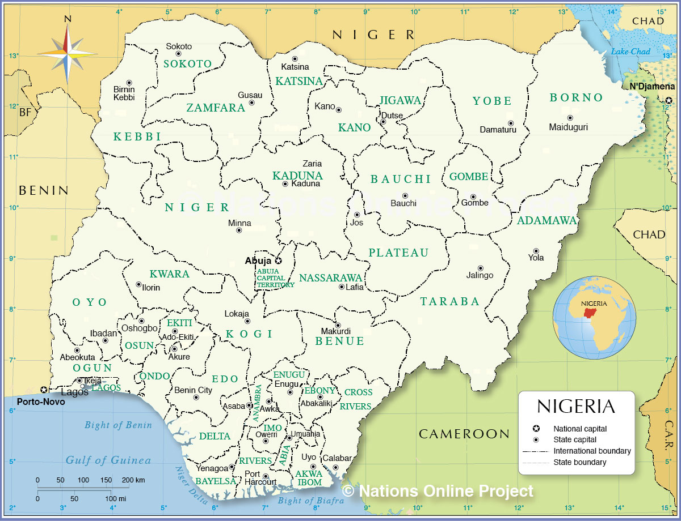

**MAP OF AKWA IBOM STATE**

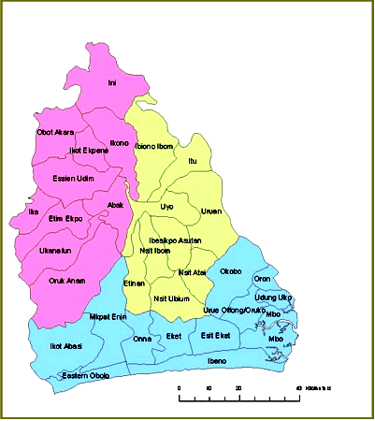

**MAP OF IKOT EKPENE**

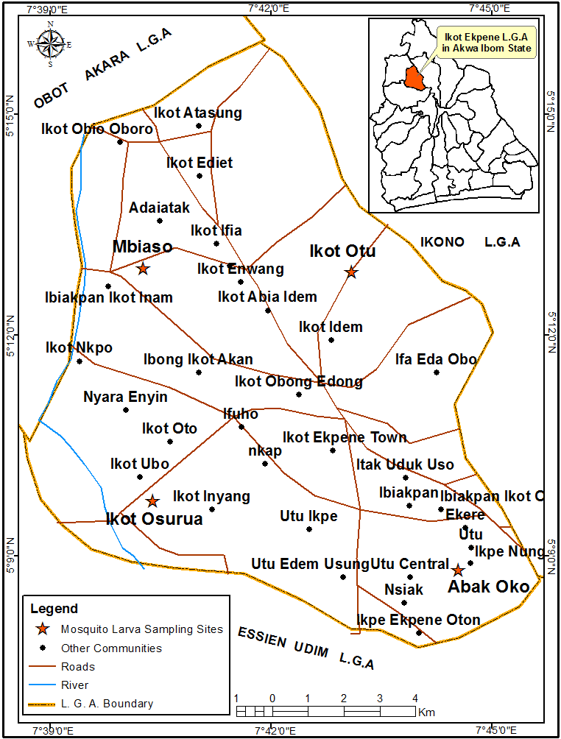

**CLIMATE**

The rainy season is humid, oppressive, and cloudy in Ikot Ekpene, whereas the dry season is warm, muggy, and usually gloomy. The average annual temperature ranges from 68°F to 87°F, with occasional exceptions when it falls below 61°F or rises over 90°F.

The best time of year to visit Ikot Ekpene for hot-weather activities, according to the beach/pool score, is from late November to early February.

**SOILS**

Although the soils of Akwa Ibom State's Ikot Ekpene region are loose and severely worn, they still sustain extensive agricultural activity in the geological zone. By using both organic and inorganic fertilizer, some other issues that could lead to low productivity can be resolved. Only good management methods can alleviate structural and other physical limitations.

**SOCIAL ACTIVITIES**

Ikot Ekpene is renowned as a hub of trade in the region. Notable exports include yams, cassava, taro, corn, raffia goods like fibers and wine, and palm products, particularly palm oil and kernels.

The South Southern Nigerian region of Ikot Ekpene, Akwa Ibom, hosts the Annang Festival of Arts and Culture, also known as AFAC. The event was started in 2016 with the goal of preserving the history, language, and culture of the Anaa. The festival strives to stop the demise of the Annang tradition and its cultural assets. It highlights and advertises the abundant natural resources of Annang area in Akwa Ibom State.

The Annang Festival of Arts and Culture Foundation is a registered foundation that belongs to the AFAC.

**LAND USE IN IKOT EKPENE**

The purpose(s) for which people use a piece of land is/are referred to as the land use definition. There will be a variety of uses for various sorts of land. Human behavior, demographic shifts, and population movement can all affect how land is used.

Some rules and regulations safeguard and ensure that land is used safely and fairly because it is a limited resource that everyone needs and uses.

The major land usage in Ikot Ekpene include:

* **Agricultural** land use is land used for growing crops such as corn, wheat, beans, etcetera, and orchards and vineyards. It also includes land used in raising and grazing farm animals such as cattle, sheep, pigs, etcetera.
* **Commercial** land use is land that has been zoned for use in the sale of goods and services for financial profit. Examples of commercial land use include central business districts, shopping districts such as large or strip malls, and many kinds of health and personal services.
* **Transport** land use is the land delegated to the moving or transportation of goods and people from one spot to another. Examples include roads, highways, railroads, and airports.
* **Residential** land use is the land used for housing. It includes single-family units with yards to multiple-unit structures such as apartment complexes, condominiums, and town homes.

**CULTURE AND RELIGION**

After the yam harvest, the Anang have a masquerade to commemorate the arrival of ancestor spirits, or ekpo. They do this in the Annang language. Additionally, a men's organization with significant historical sway over Ibibio communities goes by this name. Iliok, frightening masks carved by the Anang, are thought to be dangerous and are only permitted for viewing by ekpo members. Other masks represent the mfon, or beautiful spirit. Christianity and pagan religion are the two main religions practiced in Ikot Ekpene.

Men continue to hold the position of leadership within the family, lineage, village, or clan, and lineage links continue to exist even after marriage. In the traditional village way of life, there are numerous societies and associations (Ulim, also called "udim") for both men and women. Both the quantity and variety of memberships in Ulim as well as the accomplishments of one or more Ulims are used to gauge an individual's worth. Elderly males, known as the Afe Ichong, serve as the legislative branch of government under the direction of the Abong Ichong (Village Top and Clan Chief), who serves as the head and chief executive but has no further power. A chief's position may be inherited or filled by the Afe.

**CHAPTER THREE**

**STATEMENT OF THE PROBLEM**

**Circulation Problem**

The area is heavily populated, particularly near the road. However, there is an equitable flow and distribution of individuals throughout the area.

**Drainage Problems**

The drainage system was not properly maintained, and waste has blocked the free flow of water along the drainages, resulting in inadequate water flow during periods of heavy rainfall.

**Waste Disposal and Management problem**

There is no organized waste management system in the area. Since the majority of waste is disposed of at the individual's choice (the disposer). which ultimately results in the removal of certain conifers and roadside graves.

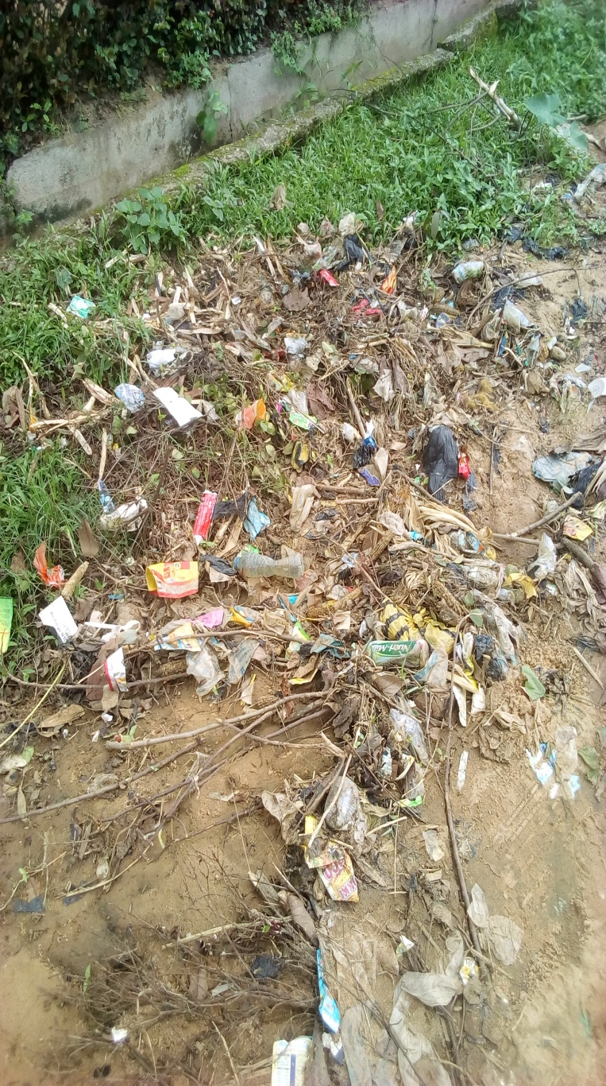

**High Land use/Building**

There are many bungalows and a few high-rise buildings present. Additionally, the majority of the land is used for residential and commercial uses, including markets, shops, and other commercial establishments.

**SOURCE OF DATA COLLECTION**

The two sources used for the data collection in this survey were primary and secondary sources.

**Primary Source**: this were obtained through in-person interviews and casual observation.

**Secondary source**: this source of data includes materials such as journals, publications, newspapers, internet etc.

**TABLE SHOWING GOOD, FAIR AND BAD BUILDINGS**

|  |  |  |  |  |
| --- | --- | --- | --- | --- |
| **TABLE SHOWING HOUSING CONDITIONS IN THE STUDY AREA** | | | | |
| **Streets** | **Good** | **Fair** | **Bad** | **Total** |
| Chubb Road | 45% | 40% | 15% | 100% |
| Alderton Road | 35% | 55% | 10% | 100% |
| Nwa-Eyen Road | 10% | 60% | 30% | 100% |
| Umuaha Road | 50 | 30 | 20 | 100% |

**PROPOSAL FOR ROAD**

The proposal for road in the study area is double lane, due to the high and intensive traffic on these roads which has resulted in many and concurrent accidents on the road exception of Nwa-eye road.

**PROPOSAL FOR DRAINAGE**

The drainage system needs maintenance and proper clearing since most the drainage system is blocked with refuse and sand.

**PROPOSAL FOR WASTE DISPOSAL**

A standard waste management system is proposed for this study area, such as the installation of waste bin along the road to enhance accessibility in order the reduce the level of incessant disposal of waste along the road.

**PROPOSAL FOR WASTE MANAGEMENT**

The proposal for the study area on waste management is mainly dependent on the season of the year, but the waste management system that could be use are incineration and land filling.

**CHAPTER FOUR**

**CONCLUSION**

Urban renewal has been governed by different principles over time, from the modifications made in the early nineteenth century to the postwar period, which were marked by strategies aimed at prioritizing perception, functionalist needs, and the low inclusion of local society in decision-making processes. Renovation projects developed usher in a new moment in which the participation of the local community gradually grows. Currently, the inclusion of residents has been encouraged at different stages, from planning through execution and implementation.

**RECOMMENDATION**

From the observation of the study

1. There is need for installation of proper waste disposal system to curtail the disposal of waste incessantly
2. The drainage system also needs revitalization to afford the free flow of water during high rainfall.
3. Also, some of the buildings in some areas like the Nwa-eyen needs renovations to boost urban status and promote economic activites.

**REFERENCES**

Akpan, N. U. (1967) Epitaph to Indirect Rule: A Discourse on Local Government in Africa, London, Frank Cass & Co Ltd.

Ekanem, J. B. (2002) Clashing Cultures: Annang Not(with)standing Christianity – An Ethnography. Brussels. Peter Lang.

Ette, E. (2020) Acculturative Stress and Change in Nigerian Society, Landham, Maryland, Lexington Books.

Ette, E. (2010) Annang Wisdom: Tools for Post Modern Living. Bloomington, Indiana Xlibris

Peacillia, Martin Chiefuna; Umanah, Victor Sunday (2013-01-01). ["An Overview of Ethical Significance of Annang Proverbs"](https://www.researchgate.net/publication/342360742_An_Overview_of_Ethical_Significance_of_Annang_Proverbs_In_World_Multidisciplinary_Journal_of_Research_Development_and_Reformation_WOJORDAR_School_of_Maritime_Studies). World Multidisciplinary Journal of Research Development and Reformation (WOJORDAR). School of Maritime Studies, Maritme Academy of Nigeria, Oron- Akwa Ibom State. **1**: 107–117.

Malachy, Okwueze; Umanah, Victor Sunday (2015-01-01). Written at Uyo, Nigeria. ["Religious Importance Of Annang Proverbs"](https://www.researchgate.net/publication/342360932_Religious_Importance_of_Annang_Proverbs). Department of Religious and Cultural Studies. Journal of Religious Studies. University of Uyo. 8: 22–39.