**A**

**TECHNICAL REPORT FOR THE PROPOSED URBAN RENEWAL OF OLD ITU ROAD IN IKOT EKPENE**

**WRITTEN BY**

**JOSEPH, ETIMA DONATUS**

**AKP/ENV/ESM/ND2020/00561**

**COURSE TITLE: URBAN AND REGIONAL PLANNING**

**COURSE CODE: URP 111**

**SUBMITTED TO**

**COURSE LECTURERS**

**TPL. DR. KOFFI AYADU**

**DEPARTMENT OF ESTATE MANAGEMENT AND VALUATION**

**AKWA IBOM STATE POLYTECHNIC**

**IKOT OSURUA, IKOT EKPENE**

**JULY, 2022**

**CHAPTER ONE**

**INTRODUCTION**

Urban renewal can be traced back to the earliest days of urban development, and was noted by those who witnessed the overcrowded conditions of 19th century in London, New York, Paris and other major cities of the developed world affected by the industrial revolution. This is a programme of land development in areas of moderate to high density urban land use and has had both successes and failures. It involves the relocation of businesses, the demolition of structures, the relocation of people, and the use of eminent domain as a legal instrument to take private property for city-initiated development projects. This process when carried out in rural areas is referred to as village renewal, though may not be exactly the same in practice.

Urban renewal is a process where by a neighbourhood in or near an urban area is transformed by demolishing old structures, renovating or building some structures, building new and modern structures and infrastructures that redefine the neighbourhoods. Agbola (1987) on the other hand defined urban renewal as a relatively comprehensive community redevelopment programme through which a particular city seeks to re-fashion and rebuild the physical structures of a particular segment of the city in order to enable it to cope more successfully with the problems confronting it.

The components of urban renewal include city expansion, redevelopment, comprehensive road development, redesigning and beautification of settlement layout, upgrading of facilities and public goods and services, repair, construction and silting of drainage system within an urban centre, and enforcing slum upgrading and city development. Although, most towns in Nigeria are experiencing these urban renewal components but the rates of increase in urbanization and poverty are militating against these developments

**DEFINITION OF THE PROJECT**  
Urban renewal project is the process of making a poor area of a city attractive for people to live and work in again by, building new houses, offices, schools, etc. and improving the existing ones.

**AIM**

This field survey aim was to observed the state of the surveyed area in order to ascertain if there is need for urban renewal intervention by the Government.

**OBJECTIVE**

* To provide for adequate expansion of the existing social facilities and establishment of new ones where needs arises.
* To minimize waste in construction, maintenance and controls of utilities and infrastructures through efficient land use.
* To arrange the existing land use in order to have a compatible and effective land use system.

**SIGNIFICANCE**

1. The government, the town planning committee, and other appropriate agencies will value this report as a basis for deliberation and decision-making.
2. The students will also gain from this study by using it as a source of data for comparison and reference purposes.
3. The environment of this region is to be arranged in such a way or manner, so as to make the beauty of the place evident. This environment has to be made functional and safe for working, living circulation, etc. through the arrangement of the land use and provision of basic lacking socio-economic and infrastructural amenities.

**SCOPE**

The study area covers only Ekanem Udom street off old Itu road in Ikot Ekpene Local Government.

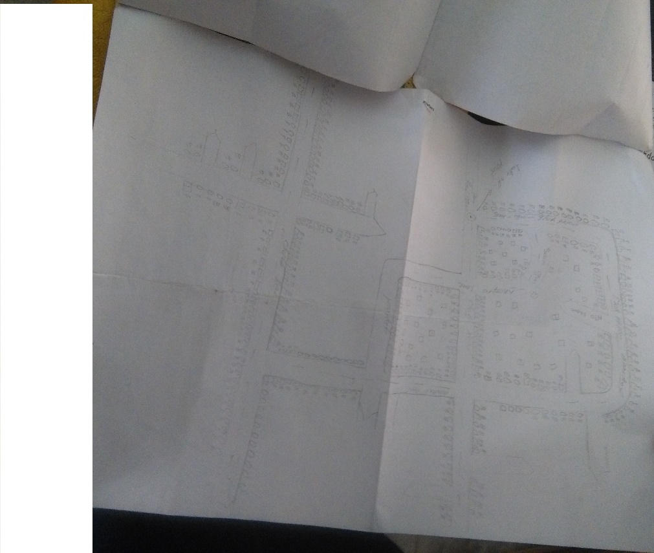

**Map of the Study Area**

**LIMITATION**

The study was hampered by the busy condition of the roads and the constant movement of bystanders, which disrupted attention a0 nd increased the amount of time spent on the survey.

The cost of transportation to the locations was also one of the constraint encountered in the process of this study

**WHY WE NEED URBAN RENEWAL**

* It drives urban productivity E.g.: Creating mixed use development projects in CBD – Creating regional hubs just outside of city limits to reduce residential and commercial pressure on inner city area.
* It creates employment opportunities
* It attracts increased investments – Intensifying use of land – Densification of area can create new market for business
* It enhance housing affordability – Brings key workers closer proximity to employment opportunities
* Capitalize on existing infrastructure – Improvement of existing infrastructure saves cost of new expensive infrastructure
* Increases tourism revenue – Improved infrastructure and services

**CHAPTER TWO**

**STUDY AREA**

The study area (Old Itu road) lies between latitude 5011` longitude 7011` in other words, the study area is in Ikot Ekpene Local Government Area, Akwa Ibom State. Nigeria. The major linking roads are Essien road at the north, Aya road at the south.

**MAP OF NIGERIA**

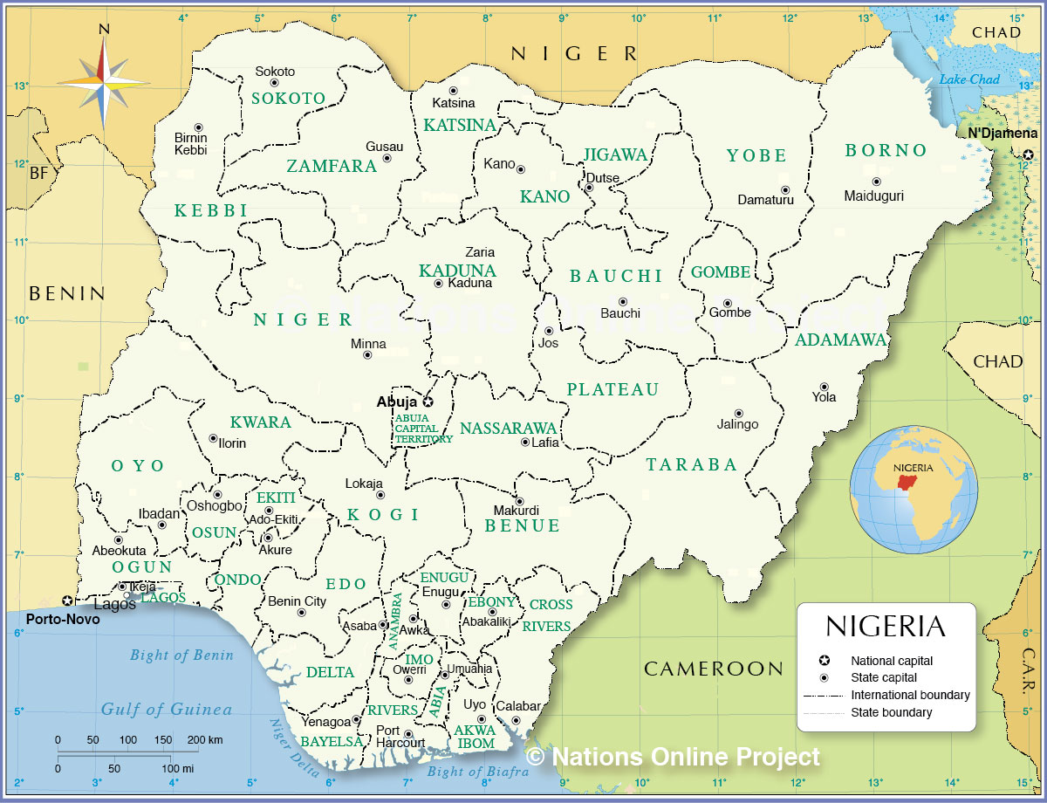

**MAP OF AKWA IBOM STATE**

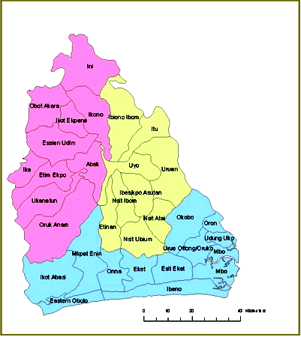

**MAP OF IKOT EKPENE**

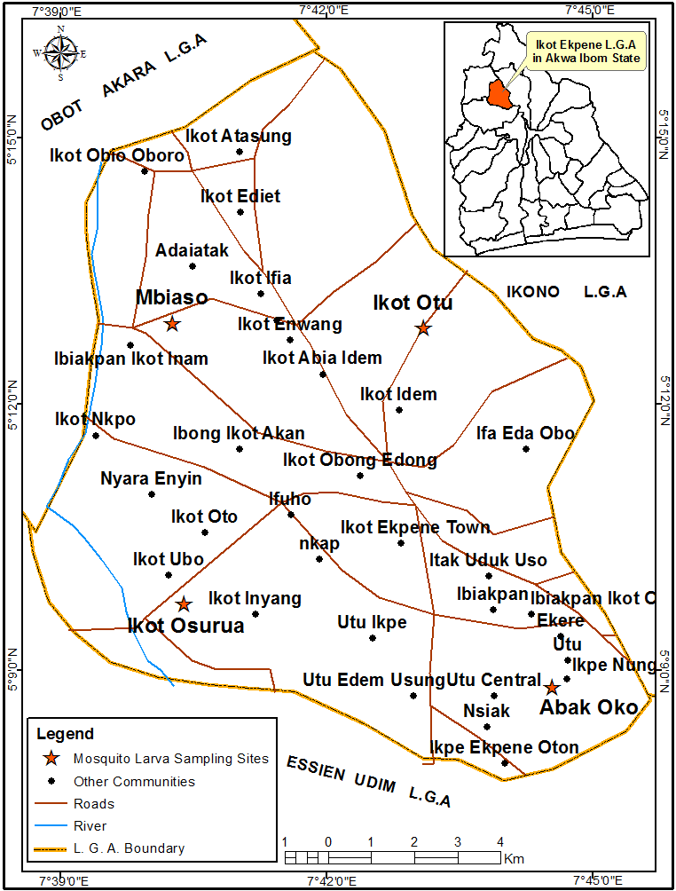

**CLIMATE**

In Ikot Ekpene, the wet season is warm, oppressive, and overcast and the dry season is hot, muggy, and mostly cloudy. Over the course of the year, the temperature typically varies from 68°Fto 87°Fand is rarely below 61°F or above 90°F*.*

Based on the [beach/pool score](https://weatherspark.com/y/55010/Average-Weather-in-Ikot-Ekpene-Nigeria-Year-Round#Sections-BestTime), the best time of year to visit Ikot Ekpene for hot-weather activities is from late Novembertoearly February*.*

**SOILS**

The soils of the Ikot Ekpene area of Akwa Ibom State are loose and highly weathered, but support intensive agricultural activities in the geological zone. Some other problems which could result in low productivity, can be ameliorated through the application of both organic and inorganic fertilizer. Structural and other physical limitations can only be ameliorated through proper management practices.

**SOCIAL ACTIVITIES**

Ikot Ekpene is known as a regional centre of commerce, with notable exports of palm products, especially palm oil, kernels, raffia products including raffia fibers and its wine, and ground crops of yams, cassava, taro, and corn.

The Annang Festival of Arts and Culture, abbreviated to AFAC, is celebrated in [Ikot Ekpene](https://en.wikipedia.org/wiki/Ikot_Ekpene" \o "Ikot Ekpene), [Akwa Ibom](https://en.wikipedia.org/wiki/Akwa_Ibom_State" \o "Akwa Ibom State), a region located in South Southern [Nigeria](https://en.wikipedia.org/wiki/Nigeria). The festival was initiated in 2016, in order to preserve the Anaañ history, language and culture. The festival aims at preventing the Annang tradition and its cultural heritage from undergoing extinction. It showcase and promote the rich natural endowments of Annang land in [Akwa Ibom State](https://en.wikipedia.org/wiki/Akwa_Ibom_State" \o "Akwa Ibom State).

The AFAC also has a registered foundation referred to as the Annang Festival of Arts and Culture Foundation.

**LAND USE IN IKOT EKPENE**

The land use definition is the function or functions for which humans use an area of land. Different types of land will be used for different purposes. How land is used can change as human habits, population change, and people move.

Since land is a finite space needed and used by everyone, some laws and regulations protect and ensure it is used safely and fairly

The major land usage in Ikot Ekpene include:

* **Agricultural** land use is land used for growing crops such as corn, wheat, beans, etcetera, and orchards and vineyards. It also includes land used in raising and grazing farm animals such as cattle, sheep, pigs, etcetera.
* **Commercial** land use is land that has been zoned for use in the sale of goods and services for financial profit. Examples of commercial land use include central business districts, shopping districts such as large or strip malls, and many kinds of health and personal services.
* **Transport** land use is the land delegated to the moving or transportation of goods and people from one spot to another. Examples include roads, highways, railroads, and airports.
* **Residential** land use is the land used for housing. It includes single-family units with yards to multiple-unit structures such as apartment complexes, condominiums, and town homes.

**CULTURE AND RELIGION**

Leadership at the family, lineage, village, or clan level remains the prerogative of the men, and lineage ties extends to women even after marriage. There are many societies and associations (*Ulim* also called "udim") for men and women which are very important in traditional village life. Individuals are measured by both the number and types of memberships in *Ulim* and by the achievements of one or more *Ulims*. Governance is done by elderly males who act as the legislative arm called Afe Ichong, directed by the *Abong Ichong* (Village Chief and Clan Chief) who is the head and the chief executive but without the authority beyond what the *Afe Ichong* gives. A chief can be appointed by the *Afe* or can be an inherited office.

The Anang speak the [Annang language](https://en.wikipedia.org/wiki/Annang_language" \o "Annang language) and perform a masquerade after the yam harvest to mark the visit of ancestral spirits, or *ekpo*. This is also the name of a men's associations that once had great influence among Ibibio groups. The Anang carve masks with grotesque features, known as *iliok*, which are considered dangerous and may only be viewed by members of the *ekpo*. Other masks embody the beautiful spirit, or *mfon*. The two major religion common in Ikot Ekpene are Christianity and paganism.

**CHAPTER FOUR**

**STATEMENT OF THE PROBLEM**

Ikot Ekpene is characterized by adverse environmental condition which is known as urban slum. Village in Ikot Ekpene show a community which has been abandoned by government with inadequate basic social amenities like; steady power supply, good roads, waste disposals e.t.c.

The residents lack proper sanitation, and solid waste are been thrown straight into the drainage which result in blockage of the drainage. Once the draining is blocked it gives way for the water to be stagnant, which in turns become a breeding place for mosquitoes that result in health problems, and it emits horrible odours that leads to air pollution. Despite the poor environmental conditions found in the settlement, Ikot Ekpene continues to grow in both population size and physical boundary. More housing unit can be seen extending into the road sides.

**Circulation Problem**

There is a dense habitation of the area, especially along the road. Nevertheless, the is even circulation and distribution of people in the area.

**Drainage Problems**

The drainage were not that maintained in proper condition as waste has impeded the free flow of water along the drainages leading to poor flow of water during high rain fall.

**Waste Disposal and Management problem**

The area does not have an established waste management system. Since most of the waste are disposed at the discretion of the person (the disposer). Which therefore leads to the logging of death in some coners and sides of the road.

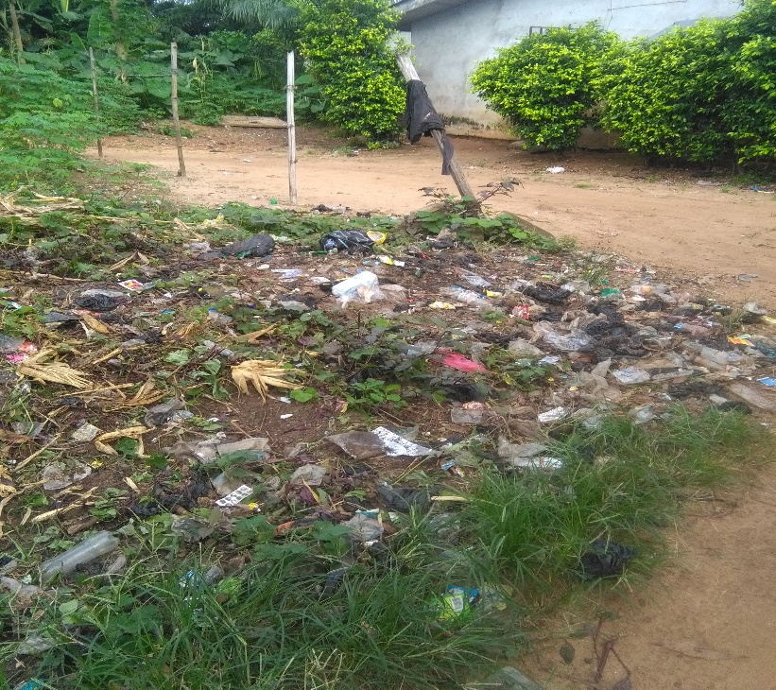

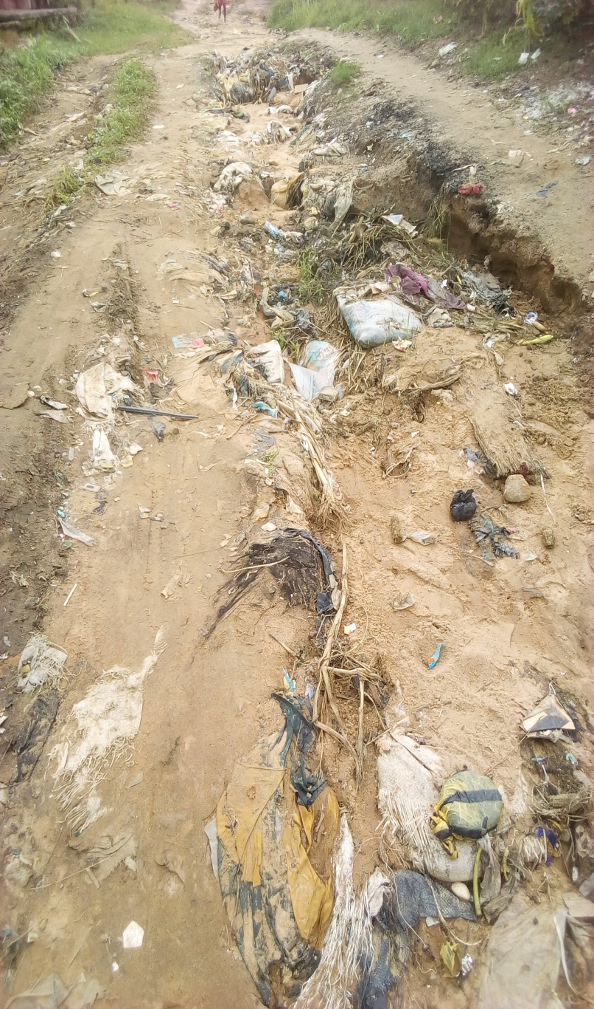

**High Land Use/Building**

There is presence of few high rise buildings and numerous bungalow. Also so, the majority of the land space are used for commercial purposes (i.e for shops, market place etc.) and residential purposes.

**SOURCE OF DATA COLLECTION**

**Primary Source**: this were obtained through in-person interviews and casual observation.

**Secondary source**: this source of data includes materials such as journals, publications, newspapers, internet etc.

**TABLE SHOWING GOOD, FAIR AND BAD BUILDINGS**

|  |  |  |  |  |
| --- | --- | --- | --- | --- |
| **TABLE SHOWING HOUSING CONDITIONS IN THE STUDY AREA** | | | | |
| **Streets** | **Good** | **Fair** | **Bad** | **Total** |
| Ekanem Udom | 45% | 40% | 15% | 100% |
| Old Firing | 35% | 55% | 10% | 100% |
| Eka Iso | 10% | 60% | 30% | 100% |

**PROPOSAL FOR ROAD**

The proposal for road in the study area is single lane, since it there are not much traffic on the road and there are no intensive business or economic transaction through the route that would warrant for road expansion.

The study also propose that the road on the study area should be upgraded and aligned with adequate drainage system due to occurrence of erosion seen n the study area due to lack of drainage facilities and as such has result in flooding during raining season.

**PROPOSAL FOR DRAINAGE**

A double road side drainage system is suitable for easy flow of water and to control erosion due to the topography of the road.

**PROPOSAL FOR WASTE DISPOSAL**

A standard waste management system is proposed for this study area, such as the installation of waste bin along the road to enhance accessibility in order the reduce the level of incessant disposal of waste along the road.

**PROPOSAL FOR WASTE MANAGEMENT**

The proposal for the study area on waste management is mainly dependent on the season of the year, but the two waste management system that could be use are incineration and land filling.

**CHAPTER FIVE**

**CONCLUSION**

Urban renewal always involved demolition of slum housing and construction of better and more costly ones. This leads to displacement and eviction of low-income residents because the costs and improvements made to the neighbourhoods increased rental rate which the original residents may be unable to pay. Consequently, environmental impact assessment of areas to be renewed must be carried out taken the original resident and the environment of the neighbourhood into account.

**RECOMMENDATION**

From the observation of the study

1. There is need for installation of proper waste disposal system to curtail the disposal of waste incessantly
2. The drainage system also needs revitalization to afford the free flow of water during high rainfall.
3. If the area (Old Itu) is considered for renovation and infrastructural installations through government intervention, there will be increase in the economic activities of the area.

**REFERENCES**

Akpan, N. U. (1967) Epitaph to Indirect Rule: A Discourse on Local Government in Africa, London, Frank Cass & Co Ltd.

Ekanem, J. B. (2002) Clashing Cultures: Annang Not(with)standing Christianity – An Ethnography. Brussels. Peter Lang.

Ette, E. (2010) Annang Wisdom: Tools for Post Modern Living. Bloomington, Indiana Xlibris

Ette, E. (2020) Acculturative Stress and Change in Nigerian Society, Landham, Maryland, Lexington Books.

Malachy, Okwueze; Umanah, Victor Sunday (2015). Written at Uyo, Nigeria. ["RELIGIOUS IMPORTANCE OF ANNANG PROVERBS"](https://www.researchgate.net/publication/342360932_Religious_Importance_of_Annang_Proverbs). Department of Religious and Cultural Studies. Journal of Religious Studies. University of Uyo. 8: 22–39.

Peacillia, Martin Chiefuna; Umanah, Victor Sunday (2013). ["An Overview of Ethical Significance of Annang Proverbs"](https://www.researchgate.net/publication/342360742_An_Overview_of_Ethical_Significance_of_Annang_Proverbs_In_World_Multidisciplinary_Journal_of_Research_Development_and_Reformation_WOJORDAR_School_of_Maritime_Studies). World Multidisciplinary Journal of Research Development and Reformation (WOJORDAR). School of Maritime Studies, Maritme Academy of Nigeria, Oron- Akwa Ibom State. 1: 107–117.