**TERM PAPER**

**ON**

**SPECIFICATION FOR A PROPOSED SIMPLE 3- BED ROOM BUNGALOW**

**DESIGN AND WITTEN BY**

**EDET, EDET EMMANUEL**

**AKP/ENV/ARC/HND2021/144**

**(GROUP 1)**

**SUBMITTED TO**

**ARC. TIMOTHY EDEM**

**(COURSE LECTURER)**

**COURSE CODE: ARC 415**

**COURSE TITLE: SPECIFICATION WRITING**

**DEPARTMENT OF ARCHITECTURAL TECHNOLOGY**

**AKWA IBOM STATE POLYTECHNIC**

**IKOT OSURUA, IKOT EKPENE**

**MAY, 2023**

**SUMMARY**



Comply with the National Construction Code, Acts, Regulations, Australian Standards and Other Standards referenced in this specification. Compatibility of Materials: Ensure materials which are used are compatible with all other materials which may be affected. For example: floor covering adhesives must be compatible with the substrate sealing system used. Making Good Repair any damages caused during the execution of the works. Leave the works and the site of the works in a neat and clean state on completion of the works. Manufacturers or suppliers’ recommendations Select, if no selection is given, and provide, transport, deliver, store, handle, protect, install, finish, adjust and prepare for use the manufactured items in accordance with the current written recommendations and instructions of the manufacturer or supplier. If materials or products are supplied by the manufacturer in closed or sealed containers or packages, bring the material or products to the place of use or installation in the original containers or packages. Proprietary Items: Identification of a proprietary item does not necessarily imply exclusive preference for the item so identified, but indicates the necessary properties of the item. If alternatives are proposed, submit sufficient information to the Superintendent to enable evaluation of the proposed alternatives. Standards: Use Standards, and their amendments, current 3 months before the date for the close of tenders except where different editions and/or amendments are required by statutory authorities, including, but not limited to, NATA and the National Construction Code including the Building Code of Australia.

**CONTENTS**

SITE PREPARATION

CONCRETE CONSTRUCTION

TIMBER CONSTRUCTION

BLOCK CONSTRUCTION

INSULATION, SARKING AND PLIABLE MEMBRANES

ROOFING

DOORS AND WINDOWS

CLADDING AND LINING

SUSPENDED CEILINGS

RENDERING AND PLASTERING

JOINERY AND FIXTURES

TILING

PAINTING

FLOOR COVERINGS

PLUMBING AND DRAINAGE

ELECTRICAL INSTALLATIONS

MECHANICAL INSTALLATIONS

FENCES

PAVING

LANDSCAPE

**SITE PREPARATION**



**Site Clearing**

Limit clearing to areas of cut and fill and areas to be occupied by works, such as structures paving, excavation, regrading, and landscape work or to other designated areas to be cleared.

Remove everything on or above the site surface, including rubbish, scrap, grass, vegetable matter and organic debris, scrub, trees, timber, stumps, boulders and rubble. Remove grassed soil to a depth just sufficient to include the root zone.

Mulch all demolished above ground vegetation and reduce to pieces not larger than 75 x 50 x 15 mm and stockpile for reuse or remove from site.

Grub out or grind stumps and roots over 75 mm diameter to a minimum depth of 500 mm below subgrade under construction, buildings, embankments and paving, and 300 mm below the finished surface in unpaved areas. Backfill holes remaining after grubbing out or grinding with sand material to prevent ponding of water. Compact the fill material to the relative density of the existing adjacent ground material.

Extent: Areas of cut or fill and areas occupied by structures, pavement and embankments.

Maximum depth: 200 mm

Stockpile site topsoil required for re-use and imported topsoil where necessary. Establish stockpiles to a maximum height of 1.5 m. Protect stockpiles from contamination by other excavated material, weeds and building debris.

Take possession of surplus material and remove it from the site. Remove cleared, grubbed and ground material from the site. Dispose of this material legally.

**Excavation**

Site surface: Excavate the site to give correct levels and profiles required for construction, site services, paving, and landscaping. Allow for compaction or settlement or heaving.

Excavate for footings to the required sizes and depths. Provide a clear space under timber or steel bearers Minimum clearance 400 mm.

Before commencing excavation, locate and mark existing underground services in the areas which will be affected by the ground works operations including clearing, excavating and trenching. Contact DIAL BEFORE YOU DIG to identify location of underground utility services pipes and cables. After excavation, confirm that the foundation conditions meet the design bearing capacity.

**Surface Preparation**

Stripping: Prepare the ground surface before placing fill (including topsoil fill) ground slabs or load bearing elements: To AS 3798 clause 6.1.5. Remove loose material, debris, organic matter and materials which will inhibit or prevent satisfactory placement of fill layers and compact the ground to achieve the required density.

**Piling**

After excavating bored piers, remove loose material and water from the base and confirm the bearing capacity. Do not allow loose material to fall down the hole before or during concreting; provide a liner if necessary.

**Service Trenches**

If practicable, make trenches straight between access chambers, inspection points and junctions, with stable sides as near to vertical as possible and uniform grades.

**CONCRETE CONSTRUCTION**



**Surface Preparation**

Any foreign materials such as oils, grease, waxes, form release agents, curing compounds, efflorescence, sealers, salts, laitance, or other contaminants must be effectively removed. Abrasive blasting should be used to prepare the surfaces. All debris shall be removed following the cleaning and disposed of in an appropriate waste facility. Acid etching may only be used for horizontal surfaces only.

**Ground Slab Vapour Barrier**

Provide a vapour barrier under slabs on ground including integral ground beams and footings. Vapour barriers and damp proof membranes: To AS 2870 clause 5.3.3.

**Reinforcement**

Provide reinforcement, including tie wires, plastic support chairs, spacers and accessories. Identification: Supply reinforcement which is readily identifiable as to grade and origin.

**Concrete**

Standard: To AS 1379, by the batch production process. Typical maximum/minimum slump: 95-80 mm. Other concrete slump may be required as shown on the drawings or in the PROJECT SPECIFIC REQUIREMENTS section of Request for Tender document. Concrete Grade Footings - N25. Exposed slabs on ground - N32. Internal slabs on ground - N25. Columns & suspended slabs - N40. Other concrete grades may be required as shown on the drawings or in the PROJECT SPECIFIC REQUIREMENTS section of Request for Tender document.

Vibrate concrete to remove entrapped air. Vibrators: Do not allow vibrators to contact set concrete, reinforcement or items including pipes and conduits embedded in concrete. Do not use vibrators to move concrete along the formwork. Avoid causing segregation by over-vibration.

**Joints**

Roughen and clean the hardened concrete joint surface, remove loose or soft material, free water, foreign matter and laitance. Dampen the surface before placing the fresh concrete and coat with a neat cement slurry. If concrete slabs are supported on masonry, provide proprietary pre-lubricated slip joints. Insert 12 mm thick Abelflex closed cell compressible filler strip in the joint. Detach the removable top strip and fill with: Fosroc Thioflex 600.

**TIMBER CONSTRUCTION**



**Standards**

Timber framing and flooring: To AS 1684 series. Design: To AS 1720.1. Anti-ponding boards: To AS/NZS 4200.2. Flashings and damp proof courses: To AS/NZS 2904. Self drilling screws: To AS 3566.1.

**Timber grades**

Hardwood: To AS 2796.1.

Grading: To AS 2796.2.

Structural Timbers: Generally F14 minimum.

Timber Trusses: To the truss manufacturer’s design.

**Timber fasteners**

Metal washers: Provide washers to the heads and nuts of all bolts and coach screws. Steel straps: Zinc-coated steel to AS 1397/Z275, minimum size 25 x 1 mm or 30 x 0.8 mm.

**BLOCK CONSTRUCTION**



**Standards**

Design: To resist actions listed in AS 1170. Masonry generally: To AS 3700 Masonry units: To AS/NZS 4455.1 and AS/NZS 4455.3. Strengthened Areas: to BCA/NCC.

Galvanizing: Galvanize mild steel components (including fasteners) to AS 1214 or AS/NZS 4680 as appropriate.

**Construction Generally**

Set out masonry with joints of uniform width and the minimum cutting of masonry units. Tool to give a dense water-shedding finish. Use a 12 mm diameter ironing rod. Internally: Rake to give a key if wall is to be plastered or strike flush if concealed. To existing: Provide a straight joint. Do not tooth new masonry into existing work. Rod: 90 mm high blocks: 6 courses to 600 mm. 190 mm high blocks: 3 courses to 600 mm. Bond: Stretcher bond unless otherwise noted. Bedding: Shell bed hollow blocks and completely fill bed joints and perpends. Perpends: Keep perpends in alternate courses vertically aligned. Building in: Build in wall ties and accessories as the construction proceeds. If it is not practicable to obtain the required embedment wholly in the mortar joint in hollow core brickwork or blockwork, fill appropriate cores with grout or mortar.

**INSULATION, SARKING AND PLIABLE MEMBRANES**



**Definitions**

Condensation: The process used to describe moisture formation on a surface as a result of moist air coming into contact with a surface which is at a lower temperature. As cool air is unable to retain the same amount of water vapour as warm air, excess moisture is released as condensation.

Insulation: Typically a material or assembly of materials intended to provide resistance to heat flow.

Pliable building membrane: Includes damp proof membrane, sarking, insulation, vapour barrier or a combination when installed in a building structure.

Sarking: A material intended to collect and discharge any water that may penetrate a building (commonly described as RFL, or reflective foil laminate). Where Sarking also forms a vapour barrier, the vapour barrier properties must conform to this specification.

Sisalation: Bonded layers of aluminium foil which may be used as a flame or water retardant. Where Sisalation also forms a vapour barrier, the vapour barrier properties must conform to this specification.

Vapour barrier: A material specifically intended to restrict the transmission of vapour. Typically used for moisture proofing.

**Materials And Components**

Cellulosic fibre (loose fill): To AS/NZS 4859.1 Section 5. Mineral wool blankets and cut pieces to AS/NZS 4859.1 Section 8. Only use biosoluble products rated FBS-1. Polyester to AS/NZS 4859.1 section 7. Polystyrene (moulded rigid cellular sheets RC/PSM): To AS 1366.3. Polystyrene (extruded rigid cellular sheets RC/PSE): To AS 1366.4. Polyurethane (rigid cellular sheets RC/PUR): To AS 1366.1. Reflective thermal insulation: To AS/NZS 4859.1 Section 9. Wool: To AS/NZS 4859.1 Section 6. Composite foam and foil blankets or boards: To AS 4859.1.

Use heavy weight materials. Standard: To AS/NZS 4200.1. Wire support to roof insulation: Use support mesh of 1.25 mm diameter galvanized wire welded in a grid of 100 x 115 mm. Safety mesh to statutory requirements may also be used to support sarking. Standard: To AS/NZS 4389. Size: 300 x 150 mm grid of 2 mm diameter galvanized wire.

**ROOFING**



**Protection**

Keep the roofing and rainwater system free of debris and lose material during construction, and leave them clean and unobstructed on completion. Repair damage to the roofing and rainwater system. Thermal movement Requirement: provide for thermal movement in the roof installation and the structure, including movement in joints and fastenings. Metal separation Requirement: Prevent direct contact between incompatible metals, and between green hardwood.

**Roof material**

Formed from G550 steel (or G300 for curving) with an AM 125 Finish conforming to AS 1397. Minimum 0.48 mm BMT. Protect the roof sheets from damage during handling and storage and prevent damage by moisture in stacked sheets. Safety mesh: Provide Safety mesh, as a fall protection barrier (fall-arrest). Comply with the requirements of the Work Health and Safety (N.U.L) Act, Regulations, and AS 4389. Prepainted Steel: Prepainted steel sheet, factory finished with a polyester finish to AS/NZS 2728.

**Thermal break**

Where metal sheet roofing is fixed to metal purlins, metal rafters or metal battens, provide a thermal break, consisting of a material with an R-value of not less than R0.2 installed between the metal sheet roofing and its supporting metal purlins, metal rafters or metal battens. Flashing material: Use material with the same finish and from the same manufacturer as the roofing sheets. Thickness: 0.55 mm BMT steel sheet.

**DOORS AND WINDOWS**



**General**

Structural design actions To: AS/NZS 1170, AS/NZS 1170.1 and AS/NZS 1170.2. Minimum clear opening: Generally 850 mm minimum clear opening. To AS 1428.1. Door furniture mounting height Standard: To AS 1428.1.

**Steel Door Frames**

Use frames assembled from zinc coated steel sections, including necessary accessories such as grommet type buffers, strike plates to suit the specified hardware, spreaders, mortar guards, switch boxes, fixing ties or brackets, and cavity flashing with suitable provision for fixing hardware; prefinished with protective coatings, built in or fixed to prepared openings.

**Timber Doors**

General Proprietary doors manufactured for interior or exterior applications and for the finish required.

Door construction

NT Designated doors

NT1 External Honeycomb-cored flush door.

NT2 External solid core flush door.

NT3 Internal Honeycomb-cored flush door.

NT4 Internal Honeycomb-cored flush door. (wet areas)

**Windows**

Design Assemblies: Design the windows and external door assemblies, including glazing, framing and fixings in accordance with AS/NZS 1170.1, AS/NZS 1170.2, AS 4055, AS 1288, and AS 2047. Pressures: Design the assemblies to be capable of resisting the most adverse combination of pressures as set out in AS/NZS 1170.2. Suction: Design the assemblies to take into account the high local suction factors as given in AS/NZS 1170 .2. Human Impact: Design the assemblies to take into account the human impact requirements as given in AS 1288.

**Construction**

Joints: Make accurately fitted tight joints so that neither fasteners nor fixing devices such as pins, screws, adhesives and pressure indentations are visible on exposed surfaces.

Insect Screens: Black anodised aluminium mesh beaded into an extruded aluminium frame and attached to the window by a clipping device to permit removal and finished to match the window frames.

**CLADDING AND LINING**

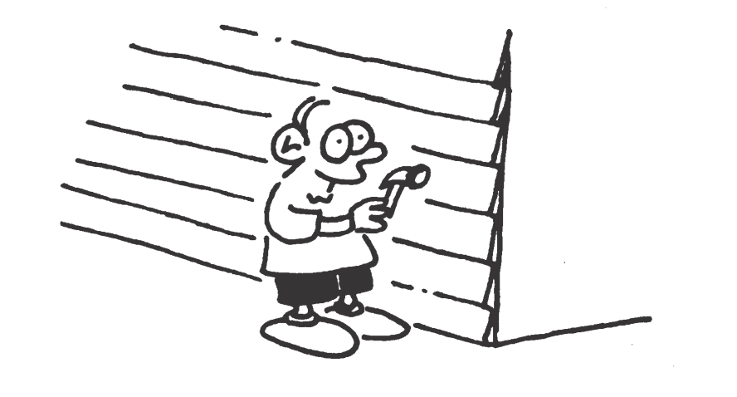

Requirement: Before fixing cladding check and, if necessary, adjust the alignment of substrates or framing.

Fixing - general Method: Nail to timber framing, screw to steel framing. Fixing – proprietary systems or products: Fix the following proprietary systems in conformance with the current written recommendations and instructions of the manufacturer or supplier:

- Fibre cement plank cladding.

- Fibre cement cladding.

- Compressed fibre cement cladding.

Accessories and trim: Provide accessories and trim necessary to complete the installation. Fixing eaves and soffit lining Nailing: In accordance with the manufacturers’ requirements and the Northern Territory Deemed to Comply Manual. Minimum at 150 mm centres to bearers at maximum 450 mm centres. Metal separation Requirement: Prevent direct contact between incompatible metals, and between green hardwood or chemically treated timber and aluminium or coated steel, by either: - Applying an anti-corrosion, low moisture transmission coating to contact surfaces, or - Inserting a separation layer.

**SUSPENDED CEILINGS**

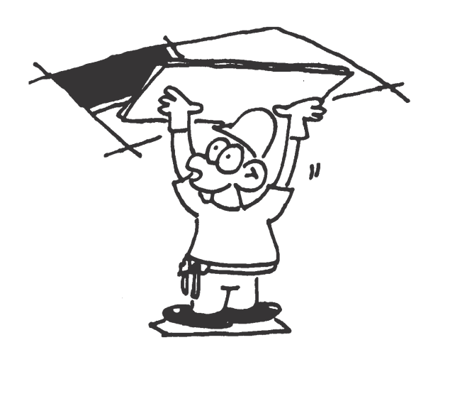

Standards Standard to AS/NZS 2785.

Performance Criteria Technical Data – Witness Point Provide technical data to substantiate compliance with the loading requirements including upward wind load.

Fixing: Approved Fixers: Install the complete system and accessories using specialist fixers approved by the suspended ceiling manufacturer.

**Materials And Components**

Zinc coated steel: To AS 1397/Z200.

Aluminium extrusions: To AS/NZS 1866.

Anodising: To AS 1231, not less than class AA10.

Thermoset powder coating: To AS 3715.

Plasterboard panels: To AS/NZS 2588.

Fibrous plaster tiles: Proprietary tiles with hard cast plaster faces.

Fasteners: Self-drilling screws: To AS 3566 series.

Powder activated fasteners: To AS/NZS 1873.4.

**Construction Generally**

Ceiling grid – Hold Point Set out the ceiling grid so that ceiling unit joints and centrelines of visible suspension members coincide with documented grid lines. If not documented, set out with equal margins.

Hold Point - Obtain approval of the set out before commencing the installation. Support members: Galvanized metal rods with a length adjustment of 50 mm. Installation: Install the ceilings level and fix so that there is no looseness or rattling of components or any of the faults described in the Appendices to AS/NZS 2785.

Provide accessories and trim necessary to complete the installation.

**RENDERING AND PLASTERING**



Standard General standard: to SA HB 161.

Interpretation: Rendering means exterior plastering

**Materials And Components**

Plaster materials Sand: Fine aggregate with low clay content and free from efflorescent salts, selected for grading and complying with SA HB 161. Cement: To AS 3972, type GP. Lime: To AS 1672.1. Gypsum plaster: To comply with the recommendations SA HB 161. Plasticizers/workability agents: Do not use in cement plasters. Accessories Metal lath: Expanded metal to AS 1397/Z350 (internal) or stainless steel or PVC (external).

Beads: Proprietary sections fixed to substrates and/or embedded in the plaster to form and protect edges and junctions.

Lime putty mixes Make a coarse mix of lime putty and sand 16 hours before use and do not allow to dry out.

Gauged mixes To improve workability, mixes required to contain only cement and sand may be gauged by the addition of lime up to 25% of the cement content, but not as a substitute for the cement.

Terminations Re-entrant corners: Finish square. Salient angles for plasterboard: Finish to manufacturers specifications.

**Substrate**

Correction of substrate: Before plastering, make good defects in the substrate. Hack off excessive projections. Fill voids and hollows with a mix not stronger than the substrate or weaker than the first coat.

Absorbent Surfaces: If suction is excessive control by dampening but avoid over wetting. Painted Surfaces: Remove paint and hack the surface at close intervals.

**Plastering**

Thickness limits: One coat work: 12 - 15 mm. Multi-coat work: - First coat: 9 - 15 mm. - Setting coat: 2 - 3 mm.

Cement rendering Proportions by volume (cement: lime: sand) for concrete and dense concrete block: 4:1:16.

White-set plaster Use 3:1 gypsum plaster: lime putty, applied as a skim coat direct to the substrate.

Waterproof render Use cement based render with proprietary waterproofing admixture.

Tolerances To SA HB-161. Finish plane surfaces within a tolerance of 6 mm in 2400 mm, determined using a 2400 mm straightedge placed anywhere in any direction. Finish corners, angles, edges and curved surfaces within equivalent tolerances.

**JOINERY AND FIXTURES**



**General**

Joinery to be fully laminated at all faces and edges unless stated otherwise. Tolerances Requirement: Fabricate and install joinery items to substrate undamaged, plumb, level, straight and free of distortion and to the Tolerances.

|  |  |
| --- | --- |
| **Property** | **Tolerance** |
| Plumb and level | 1:800 |
| Offsets in flush adjoining surfaces | 0.5 mm |
| Offsets in revealed adjoining surfaces | 2 mm |
| Alignment of adjoining doors | 0.5 mm |
| Difference in scribe thickness for joinery items centred between walls | 2 mm |
| Doors centred in openings | Zero |
| Joints in finished surfaces | Zero |

**Construction Generally**

General Construction: Build components square and install plumb. Framing: Frame and trim where necessary for openings, including those required by other trades. Accessories and trim: Provide as necessary to complete the installation. Joints: Provide materials in single lengths whenever possible. If joints are necessary, make them over supports.

**TILING**

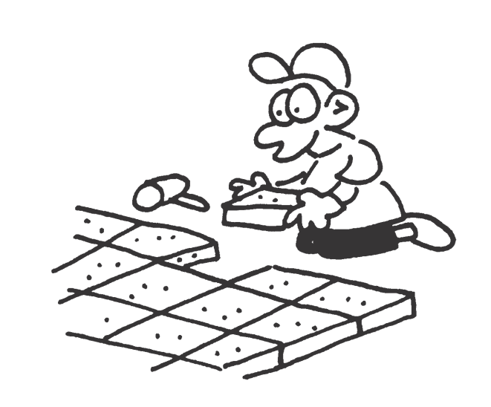

Standards Ceramic tiles To: AS 3958.1 and AS 3958.2.

Slip resistance classification of new pedestrian surface materials To: AS 4586. Tolerances Completed tiling: To AS 3958.1 Clause

**Materials And Components**

Tiles Standard: To AS/ISO 13006. Exposed edges If available, provide purpose-made border tiles with the exposed edge (whether round, square or cushion) glazed to match the tile face. Accessories If available, provide tile accessories such as round edge ceramic tiles, cove tiles, step treads and nosings to stairs, landings, and thresholds, skirtings, sills, copings and bath vents, which match the surrounding tiles, composition, colour and finish.

Adhesives Standard: To AS 2358 and AS ISO 13007.1. PVA based adhesives: Do not use in wet areas or externally.

Mortar materials Sand: Fine aggregate with a low clay content selected for grading, sharp and free from efflorescing salts. Cement: To AS 3972, type GP. 14.2.6 Bedding mortar Proportioning: Select proportions from the range 1:3 to 1:4 cement: sand by volume to obtain satisfactory adhesion. Use minimum water.

**PAINTING**



**Powder Coating**

Aluminium surfaces: To AS 3715.

Steel or zinc coated surfaces: To AS 4506. 15.1.3

‘Wet Paint’ warning Place notices conspicuously and do not remove them until the paint is dry.

Materials And Components

Low VOC Paints – Witness Point Use low VOC emitting paints. Provide manufacturer’s specifications. 1

Premium Paints Use only premium paints from approved manufacturers.

Paint Manufacturer – Hold Point Prior to placing orders provide a list showing the brand of the paint proposed for use and the trade names of the paint types referred to by generic type and APAS specification number in the painting schedule.

**FLOOR COVERINGS**



Have the floor coverings and accessories installed by experienced fixers approved by the floor covering supplier.

**Materials And Components**

Carpets Resilient finishes: Sheet/vinyl tiles.

Hardboard underlay Standard: To AS/NZS 1859.4, standard hardboard Type RD, manufactured as flooring underlay. Thickness: 5.5 mm.

Carpet underlay Needled underfelt:

Provide a felt composed of 60% animal fibre and 40% jute, reinforced with polypropylene scrim with a minimum mass of 50 g/m2 , or hessian fabric with a minimum mass of 150 g/m2 . Synthetic Foam underlay: Provide high density synthetic latex flat cushion foam sandwiched between reinforced carrier fabric.

**PLUMBING AND DRAINAGE**



**Standard**

Plumbing and drainage products: To SAA MP52,

The Plumbing Code of Australia.

The AS/NZS 3500 series.

The ATS 5200 series.

Installation: To AS/NZS 3500.5.

Swimming Pool Skimmers to AS 1926.3.

**Finishes**

Finish exposed piping, including fittings and supports as follows:

- Internal locations such as toilet and kitchen areas: Chrome plate copper piping to AS 1192 Service condition 2, bright.

- Externally: Paint.

- Concealed but accessible spaces (including cupboards and non-habitable enclosed spaces): Leave unpainted except for required identification marking. Prime steel piping and iron fittings.

- Valves: Finish valves to match connected piping.

**ELECTRICAL INSTALLATIONS**

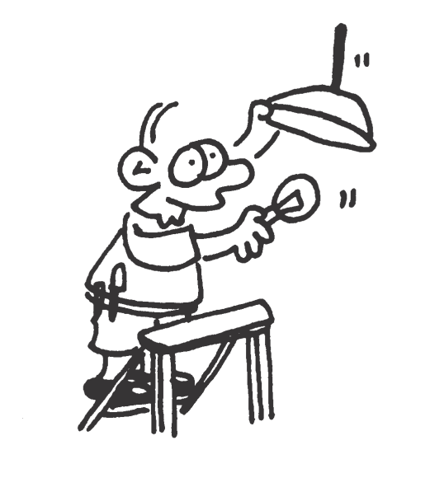

**Installation**

Wiring: Conceal cables and conduits, including underground cable or conduit entering the building, in a manner that will allow wiring replacement without structural work or the removal of cladding or lining. Do not penetrate damp-proof courses. Electrical accessories: Install flush mounted accessories in wall boxes, if required, in masonry and in mounting brackets in stud walls. Fixed appliances: Provide connections with socket outlet and flush blank plate for fixed and stationary appliances. Earth all slab fabric.

**Materials & Components**

Luminaires: To AS/NZS 60598.1.

Circuit breakers: To AS 60947.2.

Low voltage switchgear and control gear: To AS 60947.1.

Switchboards: To AS/NZS 61439.1 or AS/NZS 61439.3 as appropriate.

Domestic electricity meter enclosures: To AS 6002 and

Power Water requirements. Cables: To AS/NZS 3008.1.1.

**MECHANICAL INSTALLATIONS**



Location: Locate units where shown on the drawings or as directed by the Superintendent. Generally install condensing units on concrete plinths at ground level or mount on concrete block walls. Position condensing units so as not to cause an obstruction or hazard. Do not mount on roofs or bracket off framed walls without prior approval. Installation: Bolt units down to manufacturer’s recommendations using anti vibration mounts. Mount units in such a way as to prevent vibration and reduce operational noise to an acceptable dB level. Install refrigeration piping and electrical wiring neatly.

Clearance: Provide minimum recommended clearance around units for correct condenser air flow and maintenance requirements.

Insulation: Protect pipework insulation against ultra-violet light and mechanical damage by fitting folded Colorbond metal or proprietary uPVC covers. Cyclone

Fixings: Fix all external plant to resist cyclonic winds in accordance with the N.T. Building Act.

Electrical: Hardwire split systems from isolating switches adjacent to the outdoor units, with control wiring to the indoor units. Connect RACs to adjacent power outlet with a three pin plug and flexible cord.

**FENCES**

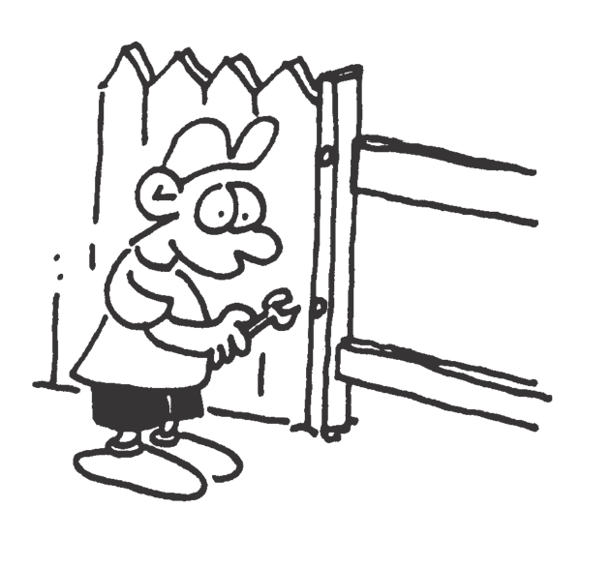

Clear vegetation, except for trees and shrubs to be retained, within 1 m of the fence alignment. Grub out the stumps and roots of removed trees or shrubs and trim the grass to ground level, but do not remove the topsoil.

Boundaries: Confirm property boundaries by survey before commencement of works. Set-out: Set-out the fence lines and mark the positions of gates, posts and bracing panels.

**PAVING**

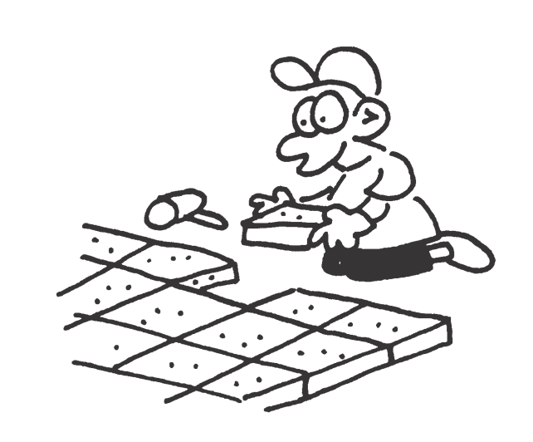

Grade paving to even falls to drain away from buildings to drainage outlets without ponding. Minimum fall for drainage: 1:100.

**LANDSCAPE**



Comply with the Acts, Regulations, Guidelines and Codes applicable to the works. Comply with the requirements of Authorities with jurisdiction over the works. Conform to the Standards and Publications quoted throughout this document unless specified otherwise.

**REFERENCED AUSTRALIAN STANDARDS**

|  |  |  |
| --- | --- | --- |
| **Referenced Australian Standards** | | |
| Use Standards, and their amendments, current 3 months before the date for the close of tenders except where different editions and/or amendments are required by statutory authorities, including, but not limited to, NATA and the National Construction Code including the Building Code of Australia. | | |
| Dates entered like this (R2013) indicate that a Standard was reviewed and re-issued unaltered in the year cited in the parentheses. | | |
| *Entries in Times New Roman italics indicate Standards not cited in this document but which may be useful references.* | | |
| AS 1012 (set) | - | Methods of testing concrete |
| AS 1012.1 | 2014 | - Sampling of concrete |
| AS 1012.8.1 | 2014 | - Method for making and curing concrete - Compression and indirect tensile  test specimens |
| AS 1012.8.2 | 2014 | - Method for making and curing concrete - Flexure test specimens |
| AS 1012.13 | 2015 | - Determination of the drying shrinkage of concrete for samples prepared in  the field or in the laboratory |
| AS 1074 | 1989 | Steel tubes & tubulars for ordinary services |
| *AS/NZS 1080 (set)* | *-* | *Timber- Methods of test* |
| *AS/NZS 1080.1* | *2012* | *- Moisture content* |
| AS 1100 (set) | - | Technical drawing |
| AS 1100.101 | 1992  (R2014) | - General principles |
| AS 1100.201 | 1992 | - Mechanical engineering drawing |
| AS 1100.301 | 2008 | - Architectural drawing |
| AS 1100.401 | 1984  (R2014) | - Engineering survey and engineering survey design drawing |
| AS 1100.501 | 2001  (R2014) | - Structural engineering drawing |
| AS 1111.1 | 2015 | ISO metric hexagon bolts & screws – Product Grade C – Bolts |
| AS 1141.11.1 | 2009 | - Methods for sampling and testing aggregates - Particle size distribution-  Sieving method |
| AS/NZS 1163 | 2016 | Cold formed structural steel hollow sections |
| AS/NZS 1170 (set) | - | Structural design actions |
| AS/NZS 1170.0 | 2002 | - General Principles |
| AS/NZS 1170.1 | 2002 | - Permanent, imposed and other actions |
| AS/NZS 1170.2 | 2011 | - Wind actions |
| AS 1192 | 2004 | Electroplated coatings – Nickel and chromium |
| AS/NZS 1214 | 2016 | Hot-dip galvanized coatings on threaded fasteners (ISO metric coarse  thread series) |
| AS/NZS 1221 | 1997 | Fire hose reels |
| AS 1231 | 2000 | Aluminium and aluminium alloys - Anodic oxidation coatings |
| AS 1288 | 2006  (R2016) | Glass in buildings - Selection and installation |
| *AS 1289.5* | *2000* | *Methods of testing soils for engineering purposes - Soil compaction & density tests* |
| AS 1289.5.1.1 | 2003 | - Determination of the dry density/moisture content relation of a soil using  standard compaction effort |
| *AS 1289.5.4.1* | *2007* | *- Compaction control test – Dry density ratio, moisture variation and moisture ratio* |
| AS 1324.1 | 2001 | Air filters for use in general ventilation and air conditioning - Application,  performance and construction |
| AS/NZS 1328.1 | 1998 | Glued laminated structural timber - Performance requirements and minimum  production requirements |
| AS 1366 (set) | - | Rigid cellular plastics sheets for thermal insulation |
| AS 1366.1 | 1992 | - Rigid cellular polyurethane (RC/PUR) (+Amendment 1:1992) |
| AS 1366.3 | 1992 | - Rigid cellular polystyrene - Moulded (RC/PS-M) |