CHAPTER ONE
1.0 INTRODUCTION
Tourism is a service industry that takes care of visitors when they are away from home. Also, tourism is defined as sum of the phenomenon and a relationship arising from the interaction of tourist and host communities in the process of attracting and hosting these tourists, and other visitors (Fadahunsi, 2003) this definition shows that tourism is interactive in nature. There are basically three broad types of tourism. They are; Cultural, Ecological and Religious (Aremu, 2001)
Tourism has emerged as one of the world’s major’s socio-economic sectors, and has been steadily expanding at an average rate of about 4-5 percent annually during the latter half of the 20th century. The combination of domestic and international tourism is now acknowledged as comprising the world’s largest industry. In 1995, tourism globally generated an estimated united state dollars of 3.4 trillion in gross output contributing 10.9 per cent of the world’s gross domestic production (GDP), creating employment for about 212 million people and producing united state dollars of 637 billion in government tax revenues.(Guide for Local Authorities on developing sustainable tourism 2001)

1.1 BACKGROUND TO THE STUDY
Tourism is one of the major sources of income in the world today and an important export industry and chief of foreign exchange in many countries like United States of America (U.SA.), United Kingdom (UK), Germany, China, and Austria while African countries like Kenya and Zimbabwe have approximately 80% tourists coming into their countries primarily for wildlife (Graham-Douglas, 2008)International tourist arrivals reached a record of 982million, an increase of 4.6% in 2010, while receipts grew by 3.8% to US$1.030billion (£740bn) (UNWTO, 2011). Tourism is now the greener pastures most developing countries have focused attention to due to its enormous benefits like infrastructural development, job creation, conservation of environment etc (Odum, 2010). In Nigeria, it is an important sector that has not fully developed, though; it is one of the country’s fastest growing industries (Oladipo, 2010). Recently, it is contributing about 3% of Nigeria GDP (Nigeria Tourism Master Plan, 2006).
Tourism has historically been dependent on the character of the destination, including attractions, beaches and resorts. It is a complex activity that requires the availability of certain parameters (e.g. accessible road networks, standard accommodation facilities, attractions etc) and information on potential and existing attraction sites. Information on these parameters and attraction sites can be gathered, processed, organized and stored using tools such as Global Positioning System (GPS), Geographic Information System (GIS) coupled with remote sensing. After gathering the needed data about a destination, the data must be stored in a retrievable form to enhance tourism, and this can be achieved with the aid of GIS (Aboyeji, 2000).
Geographic Information Systems (GIS) is one of the most remarkable technologic innovations in tourism planning and decision making. “Both GIS and tourism share a common characteristic, that is, both cross the boundaries of disciplines and application areas. GIS has been applied in many fields including geography, forestry, urban development and planning, and environmental studies. Similarly, tourism has been a subject of interest to geographers, economists, business, environmental planners, anthropologists, and archeologists” (Christou, 2002). This makes the potential applications of GIS in tourism significant. Moreover, maps have been known to play vital roles in identifying and locating tourist attractions. GIS however provides the facility to extract different sets of information (e.g. tourist attractions, hotels and their distances from one another, roads, settlements, vegetation, land use data, changes in tourism resources) from a map and use them as required (Fajuyigbe, 2007) because of the dynamic capability of GIS tools to incorporate changes that occur over time to its database.
Tourist maps in Nigeria are not easily seen or available, where available it is lacking in comprehension, accuracy and up-to date georeferencing (Ajirotutu, 2012). This paper presents the practical use of GIS to process, organize, store and disseminate already captured data on tourist attraction sites to enhance tourism development in Nigeria with special emphasis on Imo State where few attractions were mapped and used in preparing a thematic layer.

1.2 STATEMENT OF THE PROBLEM
The tourism industry in the Owerri has many difficulties about the promotion, such as the lack of graphical tourist guides and maps, lack of digital information for tourism facilities, insufficient promotion from the government and other public institutions, etc.
In our daily lives as humans, most of our endeavors involve moving from one location to another for one thing or the other. A problem emerges when there is no proper direction or a system as to give accurate direction in locating our destination, what they said destination contains and what is has to offer. This is the problem the state has as concerning tourism, whereby a good number of tourists (most especially tourists visiting for the very first time) and other individuals wanting to visit tourist sites in the state but cannot do so because of the lack of a well detailed system to provide them (tourists) with an accurate geographic information system as to how to locate these sites within the state. Due to the lack of an accurate geographic information retrieval system as far as tourism is concerned, most tourists are discouraged from exploring these tourist locations within the state, this in turn hampers the positive impact that tourism is meant to have on the development in the state and the Nigerian society at large.

1.3 AIM OF THE STUDY
The aim of the project is to produce a tourism map of Owerri using Geographic Information System (GIS).

1.4 OBJECTIVES OF THE STUDY
- To provide spatial location of tourist site in Owerri
- To provide road map that can be use to trace tourism site within the study area.
- To create spatial database of tourist sites and their attributes.
- To provide some hotel information for tourist such as availability of ATM, Bar, Spa, etc
- To carry out queries from the database

  - RESEARCH QUESTIONS
This work will give answer to the following questions;
- Can Geographical information system help in improving tourism management in Owerri, Imo state?
- To what extent is geographic information for tourism is provided for tourists in and outside the state?
- What are the possible solutions to the factors affecting effective implementation of GIS in tourism sector in Owerri?

  - SIGNIFICANCE OF THE STUDY
The significance of this study is to show that a link between geography and other professions can be created on the platform of information technology. i.e. to show that with information technology the problem of location can and is solved to a very large extent.
Among the benefits of using GIS to manage Tourist centers in the study area are to create awareness of these tourist centers, to improve the management methodology of the tourism industry and effectiveness in the policy and decision making by the government.
Maps are a natural means of indexing and presenting tourism related information. Therefore this work will help Travelers that are using maps to navigate during their travels and for preparing their routes. Moreover, maps exploit the two dimensional capabilities of human vision and present the information in a compact and “easy to read” way.
It will also serve as a reference materials to students and scholars who will carry out further research on the GIS and Tourism development in Nigeria as it will add to existing literature on the subject matter.

  - SCOPE OF STUDY
This project involves the digital update of Owerri map in GIS environment. Reconnaissance, acquisition of satellite imagery data covering the study area, geo-referencing/rectifying of the scanned Owerri street guide map using ArcGIS software, vectorizing the features in the imagery within the extent of the area, cartographic embellishment, initial printing of the updated map are among the scope outline. This work is capital intensive bond requires some amount of man power but less compared to convention technique which is not readily available.

  - LIMITATIONS OF THE STUDY
Time was a major constraint faced during the research for this project work and limited the effort in developing a much more comprehensive package needed in the design and implementation of the geographic information system. Taking into consideration what is expected to be done within a limited period of time in terms of area to be covered in a specific duration, it will not be easy to reach out to all tourist centers in the study area, more so, due to the distances from one tourist attraction to another in the same area of study, tracking of gps satellite locating a place, inaccessibility due to bad roads and less corporation of some agencies in most tourist centers. The analysis carried out for this project was for tourists in Owerri only.

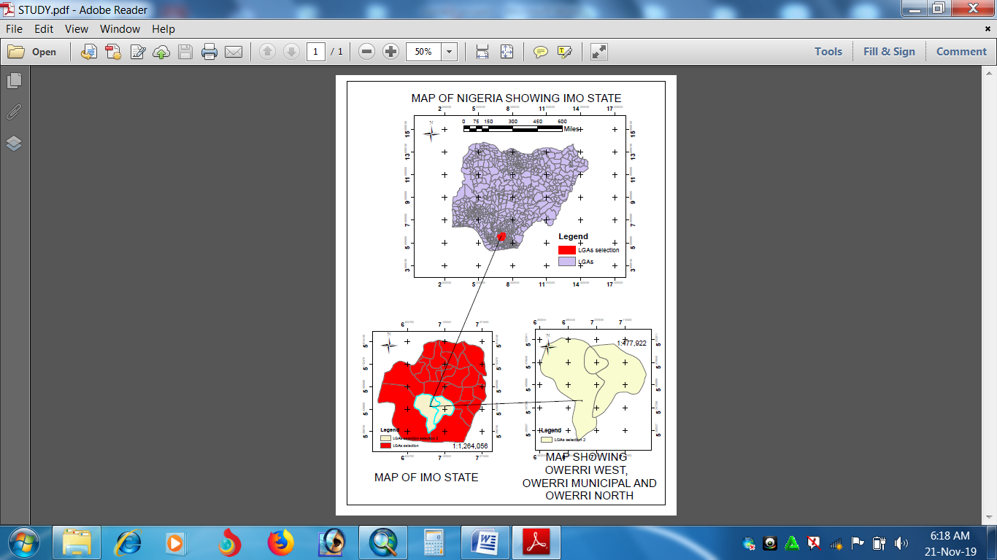
  - STUDY AREA

Fig. 1: Map Showing Nigeria, Imo State, And LGs In Owerri
SOURCE: Office of the Surveyor General of the Federation (OSGOF) MAP 2019

OWERRI
owerri is the capital of Imo state, one of the Nigeria’s south eastern cities native to the Igbo ethnic group. Owerri is bordered by the Otamiri River to the east and the Nworie River to the south, Owerri can be aptly described as Nigeria’s entertainment capital. The city’s nightlife testifies to this fact. Every weekend, patrons flock Owerri from neighboring states to dance, drink, party and have fun at the popular hangouts, joints, restaurants and bars that dot the city. Its and Igbo speaking area but almost all can communicate in English language. Education is not taken for granted in Owerri Imo state; it has notable institutions like Federal University of Technology Owerri, Federal polytechnic Owerri and some other institutions.

1.10 DEFINITION OF TERMS
The following terms will be defined for easy clarity and understanding;
GEOGRAPHY: Geography is a science that deals with the distribution and arrangement of all elements of the earth’s surface. The word geography was adopted in the 200s BC by the Greek Scholar Eratosthenes and means „earth description.‟
INFORMATION SYSTEM: An information system can be defined technically as a set of interrelated components that collect (or retrieve), process, store and distribute information to support decision making and control in an organization.
GEOGRAPHIC INFORMATION SYSTEM: Is an information system which has the capability to handle spatially distributed data, relate them to other numerical or descriptive data, and present the data visually on a map, reports, chart etc.
LOCATION: The position, site or sitting of somebody or something.
MAP: A diagrammatic drawing of something such as a route or area made to show the location or how to get there.
TOURISM: Travel to benefit from a particular service or activity that is unavailable at home.
COMPUTER : An electronic device that can accept data/ information inform of input , process the data /information in order to produce an output and also has the capability to store the information for future use.
DATA: Data refers to raw or unprocessed information.
SOFTWARE: This is the logically written instruction that controls the operations of the hardware.
HARDWARE: This is the physical components of computer system and other geographic tools or devices.
DATABASE: This is the collection of related data/ information stored mostly in a central location.
COMPUTER AIDED DESIGN (CAD): Software programs for the design, drafting and presentation of graphics. Originally designed for manufacturing and drawing, now also widely used for mapping.
OPERATING SYTEM: A series of computer programs which control the operations of the computer itself. Application programs such as GIS software run under an operating system. Examples of operating system include UNIX, VMS, and DOS etc.

