**TABLE OF CONTENT**

**CERTIFICATION**

**DEDICATION**

**ACKNOWLEDGEMENTS**

**LIST OF TABLES**

**CHAPTER ONE**

**INTRODUCTION**

1. BACKGROUND INFORMATION
2. MEANING OF ENVIRONMENT
3. RELIGION AND ENVIRONMENT
4. STATEMENT OF PROBLEM
5. SIGNIFICANCE OF THE STUDY
6. AIM AND OBJECTIVES
7. STUDY AREA
8. SCOPE OF PROJECT
9. ORGANIZATION OF THE STUDY
10. LIMITATION OF THE STUDY
11. DEFINITION OF TERMS
12. RESEARCH QUESTIONS

**CHAPTER TWO**

**LITERATURE REVIEW**

2.0 INTRODUCTION

2.1 ENVIRONMENTAL DEGRADATION

2.2 RELIGION AND ENVIRONMENTAL DEGRADING

2.3 RELIGION CENTERS INTEGRATION

2.4 RELIGIOUS COMPOSITION

2.5 RELIGION AND PERCEPTION OF ENVIRONMENTAL PROBLEM

2.6 RELIGION AND THE ENVIRONMENT IN NIGERIA AND AFRICA

2.7 ENVIRONMENTAL LAWS IN NIGERIA

2.8 INTERNATIONAL ENVIRONMENTAL LAWS AND NIGERIA

2.9 THE SITUATION CONCERNING ENVIRONMENTAL LAWS IN NIGERIA

2.9.1 FORESTS

2.9.2 POLLUTION

2.9.3. WILDLIFE AND BIODIVERSITY

2.9.4 WASTE MANAGEMENT AND ENVIRONMENTAL SANITATION

2.9.5. EXECUTION OF DEVELOPMENT PROJECTS

2.9.6 RATIONAL LAND USE

2.9.7 CLIMATE CHANGE

2.10 NOISE POLLUTION CONTROL FROM LAGOS ENVIRONMENTAL PROTECTION AGENCY (LASEPA)

2.10.1 PROHIBATION OF NOISE IN PRIVATE AND PUBLIC PLACES BY LASEPA

2.11 ENVIRONMEN MANAGEEMENT PROTECTION LAW BY LASEPA FOR POWER TO MAKE REGULATION

**CHAPTER THREE**

**RESEARCH METHODOLOGY**

1. RESEARCH DESIGN
2. RECONNAISANCE

3.1.1 OFFICE RECONNAISANCE

3.1.2 FIELD RECONNAISANCE

1. DATA ACQUISITION

3.2.1 PRIMARY SOURCE

3.2.2 SECONDARY SOURCE

1. POPULATION OF THE STUDY
2. PERSONNEL
3. EQUIPMENT USED

3.5.1 HARDWARE AND SOFTWARE

1. PROCEDURE FOR NOISE MEASUREMENT
2. PROCEDURE FOR CREATION OF THE MAP

3.7.1 DATA SOURCE

3.7.2 SPATIAL DISTRIBUTION OF RELIGIOUS CENTERS (CHURCHES/MOSQUES) ACROSS ALL STATES IN KOSOFE LOCAL GOVERNMENT.

3.7.3 TO IDENTIFY THE SPATIAL PATTERN OF RELIGIOUS CENTERS IN KOSOFE LOCAL GOEVERNMENT AREA

3.7.4 DESIGN AND CREATION OF A DATABASE

3.7.5 WHAT IS A GEODATABASE

3.7.5.1 DATA BASE DESIGN

3.7.5.2 DATA BASE CREATION

3.7.5.3 POINTS OF INTEREST

3.7.5.4 DATA ANALYSIS

3.7.5.4.1 SPATIAL ANALYSIS

3.7.5.4.2 STATISTICAL ANALYSIS

**CHAPTER FOUR**

**RESULTS AND ANALYSIS**

4.1 PRESENTATION OF RESULTS

4.2 EQUIVALENT NOISE LEVELS IN CHURCHES AND MOSQUES

4.3 NOISE POLLUTION LEVEL

4.4 ANALYSIS

**CHAPTER FIVE**

**SUMMARY, CONCLUSION AND RECOMMENDATIONS**

5.1 SUMMARY

5.2 CONCLUSIONS

5.3 RECOMMENDATIONS

**REFERENCES**

**CHAPTER ONE**

**INTRODUCTION**

1. **BACKGROUND INFORMATION**

The environmental crisis has been termed one of humanity's most pressing issues due to its numerous aspects, intensity, and consequences (Gerten & Bergmann, 2012; Gottlieb, 2006; Leiserowitz, 2008). The suffering of millions of people across the world, as well as the dangers that humankind's impact on the environment poses to the planet's future and human civilization, has motivated intense efforts to reconcile human concerns with natural world dynamics. Evidence from research conducted by important international organizations over the years has warned of a terrible future if civilization fails to reverse the trend of environmental deterioration.

According to the Intergovernmental Panel on Climate Change (IPCC 2014), human-caused climatic change is primarily responsible for rapid changes in precipitation and rising sea levels, which are disrupting global hydrological systems and affecting the quality and quantity of water resources around the world. Reduced agricultural yields have been seen as a result of climate change in many parts of the world, a trend that raises major worries about food security for the world's expanding population. The Intergovernmental Panel on Climate Change (IPCC) has identified species extinction and ecosystem changes as detrimental effects of anthropogenic climate change on the natural environment. Increased rates of temperature-related illnesses, diseases caused by altering water quality and supply, and so on are some of the potential and current consequences of anthropogenic climate change on human systems. Ecosystem disruptions as a result of climate-related changes also cause social, economic, and institutional stress, particularly in 'sensitive' areas United Nations Framework Convention on Climate Change (UNFCCC, 2007). Environmental degradation has devastating effects, particularly for the world's poor, whose livelihoods are directly dependent on the physical environment and who lack the resources to adapt. While climate change is often regarded as the world's most urgent environmental problem, environmental degradation caused by human activities is also gaining traction.

According to the United Nations (UNEP, 2012), accelerated rates of resource use by a growing population and use of technology-driven production is exceeding the capacity of the earth to replenish depleted resources and reduce the negative effects of wastes. Thus, like climate change, direct degradation of the environment through human activities such as excessive deforestation, land clearance for agriculture and urbanisation, and pollution from domestic and industrial wastes are among leading causes of environmental decline. Destruction of natural habitats due to such activities is already upsetting the natural balance in the ecosystem and leading to species extinction. Extensive deforestation is a leading cause of desertification and soil degradation. Land, air and water pollution are primary causes of many health problems confronting human societies (UNEP, 2012).

Similarly, developing and implementing an effective approach to mitigating environmental problems requires an understanding of how communities perceive environmental change and how they respond to its impacts (Leiserowitz, 2008; 2003). Social theory and research on society-environment interaction are, in part, driven by the "hope for building understanding needed to effectively alter human behaviors that contribute to environmental problems" (Stern, 2000:407). In addition to gaining the understanding required to change society's negative impact on the environment, social theory and research is also profoundly influenced by the need to understand public perception Experts, policymakers, and the general public have become more concerned in recent years about finding answers to the rising challenges faced by current environmental issues. To solve environmental issues, we must change our societal values, attitudes, and actions of and responses to environmental risks. This is based on the assumption that, in order to adapt to and alleviate environmental crises, human society must positively modify public attitudes about environmental circumstances as well as the behaviors of the billions of people who are thought to contribute to environmental issues.

Religion has a recognised role in influencing attitudes, behaviour, perceptions, modes of coping and actions in response to environmental problems, and is thus seen to be an important domain of research and policy on current environmental change (Gerten & Bergmann, 2012). Evidence from empirical research suggests that religious beliefs and experience play a key role in shaping individual environmental attitudes and behaviours, and in communities' perceptions and responses to environmental change in many societies across the world (Guth, Green, Kellstedt, & Smidt, 1995; Hitzhusen & Tucker, 2013; Keans, 1996; Smith & Leiserowitz, 2013; Stern & Dietz, 1994). This thesis aims to add to current understandings of how religious beliefs and worldviews contribute to and/or mitigate environmental concerns. Its goal is to add to the ongoing social science discussions on society-environment interaction in general, and the religion-environment nexus in particular. The Kosofe Local Government Area, which is experiencing significant environmental change, was chosen as the research site to investigate religion, the environment, and societal issues. The research is motivated by the notion that religious beliefs and practices may be utilized to impact attitudes and behaviours toward the natural world, as well as shape interpretations and adaptations to environmental changes, for many individuals. The study aims to contribute to a better understanding of the socio-cultural processes that determine environmental behaviour and impact adaptation and reactions to environmental change, both in Kosofe Local Government Area, by using religion as an analytical lens.

Commentators (e.g., BBC World Trust, 2010) have reported that, compared to the rest of the world, people living in Sub-Saharan countries like Nigeria are worst impacted by the devastating effects of environmental change. Yet, there is a dearth of empirical knowledge about public understandings and responses to environmental change in the sub-continent. Further, despite the widely acknowledged centrality of religion to social structure in Sub-Saharan Africa (Pew Forum, 2010), little is known about the connections between religion and the environment. Much of the empirical research on links between religion and environmental change were conducted in the developed societies of North America and Western Europe. Thus, by focusing on one of the areas designated as a 'hotspot' of environmental change (Boko, Niang, Nyong, & Vogol, 2007) where little research is done, this thesis seeks to contribute to the existing theoretical and empirical knowledge on the social bases of environmental problems, the role of religion in shaping human interaction with the natural environment, and to environmental policy generally.

**1.0 MEANING OF ENVIRONMENT**

Varied ontologies of the ‘environment' and, as a result, divergent epistemological views on how people gain an awareness of their biophysical ‘environment' have emerged from various sociological traditions. Social constructionism is one of these significant philosophical perspectives on the idea of "environment." The concept that nature is "socially created" lies at the heart of this theoretical perspective. That is to say the ‘social processes of knowledge generation and communication’ always determine how we understand nature (Lockie, 2004: 29). Over the years, social constructionists made concerted efforts to explore the ontology of the ‘environment’. To some social constructionists (Jenkins, 2002:111), sociology has failed, from the beginning, to properly conceptualize the ‘environment,’ which has produced serious analytical constraints to the discipline's engagement with issues relating to the natural environment. Social constructionists’ effort to critically treat the taken-for-granted concept of ‘environment’ is one of their key areas of contribution to environmental sociology (Buttel et al., 2002). Their attempt to resolve the fundamental ontological question of what defines the "environment" has had a significant influence on empirical study on environmental problems' social elements. Despite the significant differences in their understanding of constructionism, social constructionists pay attention to the ‘ways in which our understandings of nature, the environment, and environmental problems are shaped by intrinsically social processes of knowledge generation and communication’ (Lockie, 2004:29).

The social constructionist approach to the environment covers a variety of perspectives on the social construction of knowledge about the natural environment, which are sometimes contradictory. At one extreme, some social constructionists maintain that nature does not possess any material reality “outside the symbolic world-building activities of humans and no way of knowing about that reality that is better than other ways of knowing” (Lockie, 2004:30). As a result, the assertion that scientific understanding of the natural environment is the sole reliable source of information about nature and its current condition is refuted by the argument that science is no better than other methods of environmental knowledge.

**1.2 RELIGION AND ENVIRONMENT**

The relationship between individuals and something which they view as sacred, typically in supernatural terms, is sometimes characterized as religion. Hundreds of millions of people follow nine of the world's main religions. There are 750 million Hindus, 10 million Jains, 700 million Buddhists, 12.5 million Jews, 1.4 billion Christians, 1.6 billion Muslims, 16 million Sikhs, and 5 million Baha'is among them. Although there is frequently a large difference between religious scriptures and actual behaviours of members of those religions, all faiths across the world have a common ethic centred on harmony with nature. Religion and the environment have a strong link. Religion has had a significant positive impact on the environment. Animism, for example, is a worldview held by many traditional peoples that establishes a spiritual bond between humans and environment. Many traditional conservation techniques are founded on various forms of animism, and sacred places have been established as a result of traditional beliefs. The Baha'i faith maintains that the natural world's majesty and diversity are deliberate representations of God. Buddhism emphasizes that respect for life in the natural environment is vital, and that all things are linked.

According to **Christianity**, all creation is a loving work of God, and mankind cannot destroy biological variety or God's creations without risking self-destruction. "For everything whatsoever befalleth the sons of men befalleth beasts... as the one dieth, so dieth the other... so that a man hath no pre-eminence above a beast," says Ecclesiastes 3:19 in the Christian Bible.Other biblical texts on wildlife protection (Deuteronomy, chapter 2, verses 6 and 7, and Genesis, chapter 9) agricultural areas (Leviticus, chapter 25, verses 2 to 4) and fruit tree preservation (Leviticus, chapter 25, verses 2 to 4) are comparable (Deuteronomy, chapter 20, verse 19, and Genesis, chapter 19, verses 23 to 25). Christmas trees come from holy woods devoted to an ancient goddess, and Christmas itself was once a pagan celebration of the winter solstice.

According to **Islam**, individuals on Earth have the position of khalifa, or trustee of God, in which they are charged with the safekeeping of the Earth and its diversity of life. "There is no animal (that lives) on the Earth, nor a creature that soars on its wings, but (forms part of) communities like you," according to the Koran (Sura 13 Aya 15). "There is a reward in doing kindness to every living creature," the prophet Mohammed is said to have said. The Jeddah Declaration on the Environment from an Islamic Perspective was adopted during the inaugural Global Environmental Forum from an Islamic Perspective, held from October 23 to 25, 2000 in Jeddah, Saudi Arabia, with UNEP as a partner. According to the Declaration, sustainable development is defined as the development and rehabilitation of the Earth in a way that does not disturb God's created equilibrium for everything in the cosmos. It goes on to say that environmental protection is a necessary component of long-term development and cannot be separated from it. States should make more efforts to accomplish economic development while also protecting the environment in a way that does not jeopardize future generations' safety and dignity. The encouragement of consumption habits defined by resource over-exploitation and waste is regarded as costly and damaging to health and the environment, therefore Islam strongly advocates water conservation. Furthermore, the idea of haram (protected zones) is fundamental to Islam.

* 1. **STATEMENT OF THE PROBLEM**

Muslims and Christians have built structures of various sizes, shapes, and magnitudes for prayer purposes, in accordance with the promise of religion to offer a home in heaven for whosoever constructs a Religious Center. Doi (1984), Adekilekun (2001) and Agbetola (1999) have given an account in their work of the origin, development and administration of the Religious Centers in the southwestern part of Nigeria.

Some religious facilities are located adjacent to important highways, resulting in narrow roadways that exacerbate obstacles and road blockage during huge crowds of worshippers on Fridays, Sundays, and other events within the worship premises, such as massive weekly programs. Some could hardly be distinguished from residential structures. The loudspeaker, which is present in different religious centers, distinguishes a section of a structure used as a religious center from a house. Loudspeakers are situated on top of religious buildings, beside or within the walls. There have been tensions between the Muslim and Christian communities, who believe that certain religious institutions in Lagos and other Nigerian towns are abusing loudspeakers.

In the 1970s, when orderliness reigned, religious centers were built with maximum conformity to planning regulations, societal overall aesthetic appeal, beauty and comfort of users and neighbors (Joseph, 1997). Aside from the large worship space, plenty of parking spots were given to discourage street parking and reduce the annoyance to other road users. Within the religious center precinct, it was customary and usual to find homes for church officials and workers, as well as small-scale or small-scale commercial buildings to produce revenue to fund church operations.

As may be seen from the above, different studies have been conducted to evaluate planning rules and standards. None of them, however, addressed the rules governing religious centers in Lagos, including how they should be established and the amount of religious centers that should be built in a given town, local government area, state, or nation.

**1.4 SIGNIFICANCE OF THE STUDY**

The research is motivated by the notion that religious beliefs and practices may be utilized to impact attitudes and behaviours toward the natural world, as well as shape interpretations and adaptations to environmental changes, for many individuals. The study aims to contribute to a better understanding of the socio-cultural processes that determine environmental behaviour and impact adaptation and reactions to environmental change in Kosofe LGA by using religion as an analytical lens. It has been noticed that whatever changes the land and environment in which we live has a direct influence on inhabitants' living conditions.

The growth of worship centres in the country, notably churches and mosques, is thwarting the Nigerian government's efforts to give her cities a touch of this areal distinction via design. “On every street, churches and mosques pop up daily,” according to researches made, without recourse to town planning rules. According to the information received one of the many consequences of Nigeria's chaotic expansion in terms of worship centres is religious strife, which is exacerbated by roadblocks during services and widespread media attention. Although these worship centres are meant to be within reach of worshipers by their very nature and purposes, the distance between them on the one hand, and to one another on the other, has severe consequences for town design.

This study is to determine the compliance level of Religious centers, if these religious centers follow the proper town planning laws and environmental regulations and to the determine the initial purpose of the land whether it is originally for Residential purpose, Recreational purpose, Educational purpose, or Religious purpose. However, the Lagos state laws do not cover how Religious centers should be built. It will create awareness to the authorities in charge of land use laws to increase the widths of laws to govern religious center so has to reduces the impact negatively on the society. It will benefit students who intends to carryout similar research as it will serve as a secondary material for the student.

**1.5 AIM AND OBJECTIVES**

The aim of this study is to determine the Compliance Level of Religious Centers to Environmental factors with a view to providing information that could enhance living for residents in Kosofe Local Government Area.

* To identify the existing environmental factors in Kosofe LGA.
* To visit the religious centers in the study area and also pick the geographical coordinates.
* To examine or determine the level of compliance of Religious Centers to these Environmental factors like Noise pollution and traffic congestion had an impact on the religious centers.
* To examine or determine the Compliance level of the religious centers to day-to-day activities in the Kosofe LGA.
* To analyze the Compliance Level and make necessary Recommendations.

**1.6 STUDY AREA**

Lagos is a megacity in South-West Nigeria, located at 060 27' 11" north latitude and 030 23' 44" east longitude. It is Nigeria's biggest and most populated metropolis, having a number of ports as well as commercial and cultural hubs.

It is Nigeria's biggest and most populated metropolis, having a number of ports as well as commercial and cultural hubs. The old city, now the commercial district, on western Lagos Island, Ikoyi Island, just east of Lagos Island, Apapa, the main port district on the mainland, low-lying Victoria Island, industrialized Iddo Island, and a group of mainland suburbs, Ebute Metta, Yaba, Surulere, Mushin, and Ikeja, are all important districts.

Lagos, with a population of 13,427,000 (2000 census estimate), is characterized by rapid, mostly unregulated growth, as a result of ongoing migration from the rest of Nigeria and neigh boring countries, as well as the challenges of its fragmented geography, which often results in chronically congested traffic conditions on city roads. Lagos is made up of 20 local governments and they include; Alimosho, Ajeromi-ifelodun, Kosofe, Mushin, Oshodi-isolo, Ojo, Ikorodu, Surulere, Agege, Ifako-ijaiye, Shomolu, Amuwo-odofin, Lagos-mainland, Iceman, Etiosa, Badagry, Apapa, Lagos island, Epe and Ibeju-lekki.

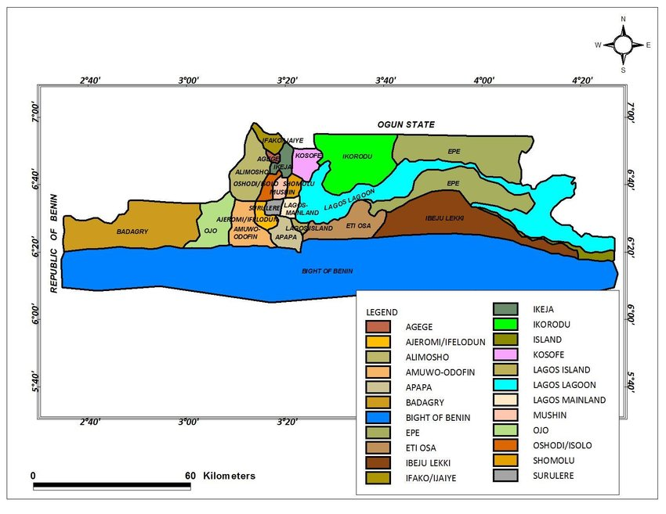

**Figure 1.1: Local government divisions are depicted on a map of Lagos state.**

Our Main Study Area which we will be looking into in this work is Kosofe Local Government Area.

Kosofe is one of Lagos State's twenty local councils. The Lagos State administration, on the other hand, formed 37 al Council Development Areas (LCDAS) out of the state's initial 20 local governments in October 2003 as a response to the people's democratic aspirations. Though Lagos is no longer the political capital of Nigeria, it remains the commercial and economic nerve center of this vast African nation, as two LCDAS, Ikosi-lsheri and Agboyi-Ketu, were created out of the former Kosofe Local Government. According to the 2006 census, Kosofe has an area of 81 km2 and a population of 665,393. The area's postal code is 100, and Ikosi is one of Kosofe's important villages.

'Nothing is free,' says Kosofe. This highlights the various economic activities that characterized the area's indigenous inhabitants and early settlers in the mid-nineteenth century, when the people were known for huge commerce in vegetables, fruits, maize, cassava, and fish. Its placement near the entrance to the Lagos metropolitan area solidifies Kosofe's position as an important name in modern-day Nigerian business. Kosofe is still a thriving commercial city today, serving as the hub for all food imports from around the country. This is reasonable given that Lagos State remains the primary market for all agricultural goods from the hinterland. As a result, today's Kosofe is mostly populated by traders, public employees, and the wealthy; little surprise the city's slogan is "cradle of excellence."

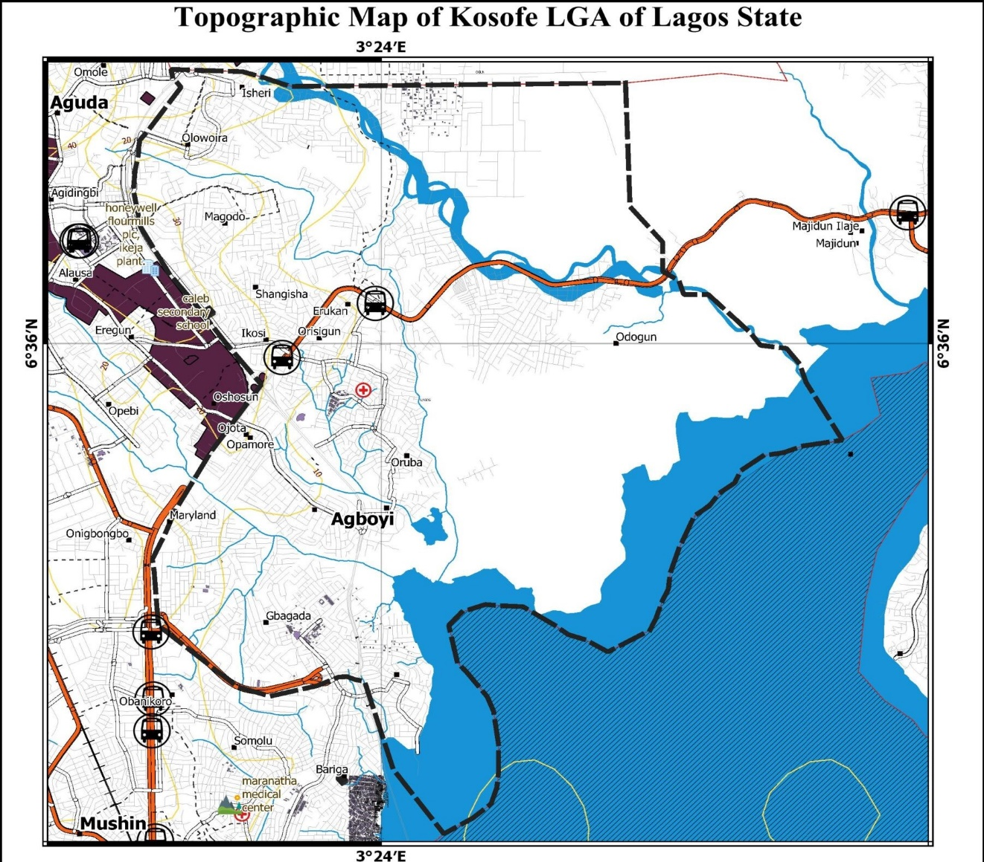

**Figure 1.2: Map of Kosofe Local Government Area**

**1.7 SCOPE OF PROJECT**

The Scope of the project to be undertaken includes the following;

* Reconnaissance
* Field work and Observation
* Data Acquisition and Storage
* Data Processing and Interpretation
* Data Presentation and Results
* Report Writing

**1.8 ORGANIZATION OF THE STUDY**

This research work is organized in five chapters, for easy understanding, as follows

Chapter one is concern with the introduction, which consist of the (overview, of the study), historical background, statement of problem, objectives of the study, research hypotheses, significance of the study, scope and limitation of the study, definition of terms and historical background of the study. Chapter two highlights the theoretical framework on which the study is based, thus the review of related literature. Chapter three deals on the research design and methodology adopted in the study. Chapter four concentrate on the data collection and analysis and presentation of finding. Chapter five gives summary, conclusion, and recommendations made of the study.

**1.9 LIMITATION OF THE STUDY**

The scope of the study covers the compliance level of religious centres to Kosofe Local Government Area. The researcher encounters some constrain which limited the scope of the study;

**a) AVAILABILITY OF RESEARCH MATERIAL:** The research material available to the researcher is insufficient, thereby limiting the study

**b) TIME:** The time frame allocated to the study does not enhance wider coverage as the researcher has to combine other academic activities and examinations with the study. The challenges experienced is the researcher will simultaneously engage in departmental activities like seminars and attendance to lectures. But the researcher was able to meet up with the deadline for the submission of the project.

**c) PRIVACY**: Limited Access to the selected auditing firm makes it difficult to get all the necessary and required information concerning the activities.

d) **FINIANCIAL PROBLEMS:** The finances or the financial situation of the researcher affected the speed of completion of the project.

**1.10 DEFINITION OF TERMS**

**PROBLEM:** A matter or situation regarded as unwelcome or harmful and needing to be dealt with and overcome.

**DEVELOPMENT:** The process of developing or being developed.

**RELIGION:** Religion is a social-cultural system of designated behaviours and practices, morals, worldviews, texts, sanctified places, prophecies, ethics, or organizations, that relates humanity to supernatural, transcendental, and spiritual elements.

**COMPLIANCE LEVEL:** Compliance levels describe the degree of compliance that a compliance program, requirement, or location has achieved by assigning the compliance level a numeric value. Having this information enables you to evaluate the compliance items that put your organization at the greatest risk of noncompliance, and to track the progress of programs, requirements, and locations in achieving compliance.

You can associate compliance levels with locations. It takes more effort to update information at the requirement and location levels, but doing so enables you to perform more detailed analysis. For example, if you want to be able to evaluate locations by their compliance level, you will need to enter and routinely re-evaluate compliance levels for your locations.

**THE ENVIRONMENT:** All that surrounds man such as water, air, land and outer space and all the contents of these milieus such as inanimate objects, flora, fauna, various forms of energy, systems and natural processes and human activities.

**ENVIRONMENTAL PROTECTION:** Preservation of the environment and prevention of its contamination and deterioration.

**ENVIRONMENTAL PROTECTION:** The presence of one or more substances or factors over a period of time in quantities or properties that will directly or indirectly be harmful to public.

**ENVIRONMENT DETERIORATION:** The negative impact on environment that changes its general nature or characteristics or the balance among its elements or loss of its beauty and appearance.

**ENVIRONMENTAL DISASTER:** An incident which causes damage to the environment and requires greater capabilities to deal with than those needed for pollution accidents.

**ENVIRONMENTAL IMPACTS:** A set of environmental reactions resulting from preparation, construction or operation of any project.

**1.11 RESEARCH QUESTIONS**

The research questions to be address in this study are as follows:

1. What is the level of compliance of religious centres at Kosofe L.G.A?
2. Does ignorant and lack of proper orientation hinders religious compliance?
3. What measures could be adopted to ensure total compliance of religious centre at Kosofe L.G.A?