MAP REVISION OF A SECTION OF OWERRI NORTH LOCAL GOVERNMENT AREA OF IMO STATE

TABLE OF CONTENT
TITLE PAGE - - - - - - - - - I
CERTIFICATION - - - - - - - - - II
APPROVAL PAGE - - - - - - - - - III
DEDICATION - - - - - - - - - IV
ACKNOWLEDGEMENT - - - - - - - - - V
ABSTRACT - - - - - - - - - VI
CHAPTER ONE
1.0 INTRODUCTION - - - - - - - - - 1
1.1 HISTORICAL BACKGROUND - - - - - - - 1
1.2 BACKGROUND TO THE STUDY - - - - - - 2
1.3 STATEMENT OF THE PROBLEM - - - - - - 4
1.4 AIM AND OBJECTIVES - - - - - - - - 4
1.5 SCOPE OF THE STUDY - - - - - - - - 5
1.6 SIGNIFICANCE OF THE STUDY - - - - - - 5
1.7 STUDY AREA - - - - - - - - - 5
1.8 LIMITATIONS - - - - - - - - - 7
1.9 DEFINITION OF TERMS - - - - - - - - 7
CHAPTER TWO
2.0 LITERATURE REVIEW - - - - - - - - 9
2.1 CONCEPTUAL FRAMEWORK - - - - - - - 9
2.1.1 WHAT IS A MAP - - - - - - - - - 9
2.1.2 WHAT IS MAP REVISION- - - - - - - - 9
2.1.3 GEOGRAPHIC INFORMATION SYSTEM - - - - - 10
2.1.4 GIS AND MAPS - - - - - - - - - 12
2.2 THEORITICAL FRAMEWORK - - - - - - - 13
2.3 EMPIRICAL FRAMEWORK - - - - - - - 16
CHAPTER THREE
3.0 RESEARCH METHODOLOGY - - - - - - - 20
3.1 INTRODUCTION - - - - - - - - - 20
3.2 PLANNING STAGE - - - - - - - - - 20
3.2.1 HARDWARE SELECTION - - - - - - - 21
3.2.2 SOFTWARE SELECTION - - - - - - - 21
3.3 DATA REQUIREMENT/ACQUISITION - - - - - 21
3.3.1 PRIMARY DATA SOURCE - - - - - - - 21
3.3.2 SECONDARY DATA SOURCE - - - - - - 22
3.4 DIGITIZATION/DATA CONVERSION - - - - - 22
3.4.1 ONSCREEN DIGITIZING - - - - - - - 23
3.5 GIS DATABASE DESIGN AND CREATION - - - - - 23
3.5.1 VIEW OF REALITY - - - - - - - - - 24
3.5.2 CONCEPTUAL DESIGN - - - - - - - - 25
3.5.3 LOGICAL DESIGN - - - - - - - - - 25
3.5.4 PHYSICAL DESIGN - - - - - - - - - 27
3.6 DATA COLLECTION - - - - - - - - - 28
3.6.1 GPS MAPPING OF LOCATION - - - - - - 28
3.6.2 COLLECTION OF ATTRIBUTE DATA - - - - - 28
3.6.3 LINKING OF DATA - - - - - - - - - 28
3.6.4 GIS ANALYSIS - - - - - - - - - 28
3.6.5 SPATIAL QUERIES - - - - - - - - - 28
3.7 METHODOLOGY FOR MAP REVISION - - - - - 29
CHAPTER FOUR
4.0 RESULTS AND DISCUSIONS - - - - - - - 31
4.1 LOCATION OF FEATURES IN OWERRI NORTH - - - - 31
4.2 DATA PRESENTATION - - - - - - - - 31
4.3 QUERY ANALYSIS - - - - - - - - - 40
4.3 DISCUSSIONS - - - - - - - - - 45
CHAPTER FIVE
5.0 SUMMARY, PROBLEMS ENCOUNTERED, RECOMMENDATIONS AND CONCLUSION - - - - - - - - - 46
5.1 SUMMARY - - - - - - - - - 46
5.2 PROBLEMS ENCOUNTERED - - - - - - - 47
5.3 RECOMMENDATION - - - - - - - - - 47
5.4 CONCLUSION - - - - - - - - - 48
REFERENCE

LIST OF TABLES
TABLE 3.1 Entity Types and Attributes - - - - - 25
TABLE 3.2 Entity Type and Declaration - - - - - 25
TABLE 4.1 Location data of the various businesses in the study area - 32
TABLE 4.2 Location data of the various Churches in the study area - 33
TABLE 4.1 Location data of the Medical Facilities in the study area - 34
TABLE 4.1 Location data of the various Hotels in the study area - 34
TABLE 4.1 Location data of the various Schools in the study area - 35

LIST OF FIGURES
Fig 1.0 Study area map - - - - - - - - 6
Fig 2.1 Levels of GIS data modeling - - - - - - 12
Fig 3.1 Plan Flow chart - - - - - - - - 19
Fig 3.2 Database design - - - - - - - - 23
Fig 4.1 Perimeter survey of study area - - - - - 31
Fig 4.2 windows display of Coordinate conversion on surfer - - 35
Fig 4.3 Masked Satellite imagery of study area - - - - 36
Fig 4.4 Digitized roads of study area - - - - - - 37
Fig 4.5 Points import on ArcGIS - - - - - - 38
Fig 4.6 Attribute Table on ArcGIS - - - - - - 38
Fig 4.7 Display of Query Builder Module on ArcGIS - - - 39
Fig 4.8 Query Result on Business Location on Study Area - - 40
Fig 4.9 Query Result on Churches Location on Study Area - - 40
Fig 4.10 Query Result on Health Facility’s Location on Study - - 41
Fig 4.11 Query Result on Hotels Location on Study Area - - - 41
Fig 4.12 Query Result on Schools Location on Study - - - 42
Fig 4.13 Statistics report on Recent development - - - - 42
Fig 4.14 New Revised Digitized Map of Study Area - - - 43

CHAPTER ONE
- INTRODUCTION
1.1 HISTORICAL BACKGROUND
Map revision is the process of updating and correcting existing maps to reflect the changes in the physical and human landscape. Map revision is essential for maintaining the accuracy and usefulness of maps, especially for purposes such as navigation, planning, and research.
The history of map revision is closely related to the history of cartography, or mapmaking, which dates back to ancient times. The earliest maps were often based on local knowledge, oral traditions, and observations, and were subject to errors and distortions. As mapmaking technology improved, maps became more precise and detailed, and map revision became more systematic and frequent.
Some of the factors that influenced the development of map revision include:
- The discovery of new lands and regions by explorers and travelers, which expanded the scope and scale of maps.
- The advancement of scientific methods and instruments, such as surveying, astronomy, and geodesy, which improved the accuracy and consistency of map measurements and projections.
- The emergence of national and international mapping agencies and standards, which established the authority and quality of official maps and their revisions.
- The invention of printing and digital technologies, which increased the availability and accessibility of maps and their revisions.
Today, map revision is a complex and dynamic process that involves various sources of data, methods of analysis, and modes of presentation. Map revision can be done manually or automatically, using techniques such as aerial photography, satellite imagery, GPS, GIS, and crowdsourcing. Map revision can also be customized for different users and purposes, such as topographic, thematic, or interactive maps

1.2 BACKGROUND TO THE STUDY
Land Surveyors the world over are aware that the provision of a topographic record of a nation's territory is expensive, time-consuming and that surveys remain extant only until such time as further natural or cultural change takes place. If this valuable asset is allowed to deteriorate its restoration to an acceptable condition is invariably more costly than its regular maintenance.
The availability of up-to-date survey data is a prerequisite for decision making by the nation's administrators in their various spheres of activity in planning, resource management, construction and property registration, to name but a few. In Nigeria, with its system of land registration based on general boundaries, the large scale maps in particular must satisfy the requirements of a variety of users, many of whom demand surveys of features as soon as they change on the ground. Failure to provide this information in the form and quality demanded would lead to potential users acquiring it through their own efforts, this in turn leading to duplication of effort and the production of topographic information unrelated to a homogeneous reference system. In addition, this information would not be available to other potential users. Eventually savings made within the national mapping organization would be more than offset by the total additional cost thrown onto map users and hence to the nation as a whole.
The choice of methods of revision vary between doing little or no revision or revising only certain features and that of maintaining a high degree of currency or "up-to-datedness" and making the survey data immediately available. The way in which revision information is made available to customers is necessarily related to the extent and frequency of revision. Clearly if large scale information is surveyed as soon as it changes on the ground then it would be inappropriate to delay its publication in some form.
The key to the success of any system of revision is in the efficient gathering of information or intelligence on changes which have taken place in topographical and cultural detail. It is unusual for such information to be volunteered to survey organizations, even National Mapping organizations; instead, it has to be actively gathered either by the survey staff themselves or by setting up an effective system of passing the appropriate information from the various sources (e.g. Planning Authorities) to the survey organization. In Nigeria, with its network of local government authorities, who are themselves either the initiators or are the authority for granting permission for others to initiate changes, it is comparatively simple to gather much of the intelligence on changes in the urban areas.
However, the system has limitations in the more rural areas where changes, although minor in relation to the amount of frequency of change in urban areas, nevertheless may be significant to the local l population. The choice of revision methods may be influenced by such factors and may need to vary between different types of area.
The world is continuously changing, everyday there is a change in the physical/natural feature of the earth due to different reasons. The need of making map revision arise due to the addition or removal of terrain features.
Maps are now becoming out of date within a short period due to rapid economic development. The availability of up-to-date map is very important in decision making for planning recourse management, construction and development.
1.3 STATEMENT OF THE PROBLEM
The maps become obsolete when information regarding the existence, position magnitude or other attributes of an included feature is inaccurate or when significant amounts of new and previously unmapped details are required to be depicted.
In the area of study this significant amount of change has been noticed but no available updated map recording the added and removed features. These updates include the addition of new features, modification of existing features and removal of non-existing features.
In the past few years, there has been rapid development of features in the Owerri North, the Naze axis and some of these features have not been mapped, therefore there is a need to provide a revised or updated map and database of the area. Some other features have been renovated, moved and some others demolished, so the study would enable a creation of an updated map and an attribute database indicating the current location and the attributes of these features. By geocoding their spatial locations and attributes using GIS approach would categorically solve these problems.
1.4 AIM AND OBJECTIVES
The aim of this project is to produce an up-to-date map of a section of Owerri North Local Government Area of Imo state using traditional ground survey, GIS and remote sensing
This will be achieved through the following objectives:
- To obtain the satellite imagery of the study area.
- To acquire some ground control points and the coordinates of new points of interest in the study area using GPS.
- To geo-reference and digitize the map using ArcGIS software in order to obtain a digital map.
- To perform spatial overlay analysis on the map.
- To produce an up-dated digital map of the study area.
1.5 SCOPE OF THE STUDY
The scope of the study is limited to a section of Owerri North L.G.A in Imo state, having an area of 4.37km². The project covers the following: office reconnaissance, mission planning, satellite image capture of the study area, Traversing, Geocoding, georeferencing and graphical digitizing, data analysis, processing and presentation. The software used are: Microsoft excel, Microsoft power point, Google Earth, Sas planet and Arc GIS.
1.6 SIGNIFICANCE OF THE STUDY
Maps are produced to show natural and artificial features information especially to visitors and researchers, considering this, there is a need to produce maps from data that can portray reality as accurate as possible in order for the rapid nature of changes is to be accommodated in a map.
GIS is an acceptable method of keeping inventory of Earth’s resources offers such powerful data gathering tools. When digitally acquired data is used to produce a map, it will take a new form and encourage new users and visualization can be possible with adequate software image manipulation and analysis can be achieved.
The result of the research will reveal the impact of digital mapping and produce an updated map of the study area, it will also assist other researchers in their work and serve as a reference material.

1.7 STUDY AREA
Owerri North is a local government area in Imo state Nigeria. Its headquarters is in the town of Orie Uratta. It is located between latitude of 01º 26’26.15” N to 1º26’35.47” N and longitude of 09º08’402” E to 09º08’268” E. it has an area of 198km² and a population of 175,395 according to the 2006 census (source: National Population Commission). The postal code of the area is 460. It encircles Owerri Municipal like a Peninsula. Six major roads that leads out of the municipal cuts across Owerri North Communities. In the North, Orlu Road leads to Akwakuma communities. In the East, Okigwe road leads to Orji. In the West, MCC road off wetheral to Obibi Uratta and Ihitaoha Communities. In the South, Mbaise road leads to Egbu and Emekuku, while Aba Road leads to Naze, Agbala and Ulakwo communities (WIKIPEDIA).
The study area covers a section of Owerri North which is at the Southern part of the local government that covers the Naze communities with an area of 4.37km².
The location study area map is as below: 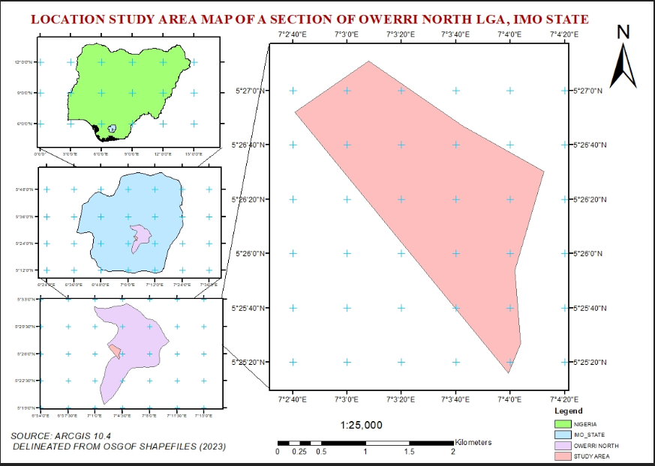
Fig 1.0 Study area map (source: delineated from OSGOF maps, Nigerian shape files, 2023
CLIMATE
Rain season normally begins in March and ends in October or early November. There are violent storms from June to July, which destroys crops and houses also. Variation occurs from year to year, and the rain is usually at its maximum at nights and early morning hours. Temperature is similar all over the state. The hottest months are January to March with mean annual temperature above 20ºc.
VEGETATION
Some economic trees like Iroko, Mahogany, Obeche, Ginelina, Bamboo, rubber, and oil palm predominates. Deforestation has triggered off acute soil erosion especially in the Amakaohia or Orji axis.
RELIGION
Christianity is the dominant religion in Owerri North, Catholics and Anglicans have the largest followers. Almost 90% of the populations are Christians and just over 80% are Orthodox and nearly 20% are Muslims.
1.8 LIMITATIONS OF THE STUDY
The first and perhaps most obvious limitation of the study lies in the data availability. Unavailability of a comprehensive base map of the study area with would foster accurate assessment on the development of in the study area. The work is capital intensive and requires some amount of manpower for ground point location which was not readily available and made it a difficult task covering the study area.
This work has been limited to the use of satellite imagery, street guide map and ground control points from GPS.
1.9 DEFINITION OF TERMS
- Attribute: Information about a spatial feature. For example, attributes about a school may be the name, level of education and number of students.
- Base Map: This refers to a collection of GIS data and/or orthorectified imagery that form the background setting for a map. The function of base map is to provide a background detail necessary to orient the location of the map.
- Coordinate Geometry: A method of defining geometric features through the input of bearing and distance measurements.
- Database: Is a collection of related data and stored in a given file.
- Database Management System: Is a system or software providing for the input, storage and retrieval of data in a database.
- Digitizing: Digitizing is the process of converting geographic data either from a hard copy or a scanned image into vector data by tracing the features.
- Geographic Coordinates: Location of features on the earth’s surface using a coordinate system of degrees of latitude and longitude.
- Geo-reference: To establish the relationship between page coordinates on a planar map and real-world coordinates.
- Network Analysis: Is a type of data analysis that allows us to find a part from one place to another.
- Remote Sensing: this is the process of detecting and monitoring the physical characteristics of an area by measuring its reflected emitted radiation at a distance (typically from satellites).
- Spatial Overlay: Allows us to determine the relationship between different geographic features

