**ROUTE SURVEY FROM YANKURA TO DAMBATTA, IN DAMBATTA LOCAL GOVERNMENT AREA,**

**KANO STATE**

**TABLE OF CONTENTS**

***Contents Page***

Title page ii

Certificate of submission iii

Approval iv

Dedication v

Acknowledgement vii

Abstract viii

Table of contents ix

**CHAPTER ONE**

1.0 Introduction 15

1.1 Background Project 15

1.2 Statement of problem 17

1.3 Aim 18

1.4 Objectives of the Project 18

1.5 Significance of project 19

1.6 Scope of project 19

1.7Personnels 19

1.8 Study Area 20

**CHAPTER TWO**

2.0 Literature review 21

**CHAPTER THREE**

3.0 Methodology 28

3.1 Reconnaissance 28

3.1.1 Office Planning 29

3.1.2 Field Reconnaissance 29

3.2 Field Preparation 30

3.3 Monumentation 30

3.4 List of Instruments used31

3.4.1 Hardware 32

3.4.2 Software 32

3.5.0 Test of instrument 32

3.6. Data Acquisition 33

3.6.1 Control Extension 34

3.7 Control Check 34

3.7.1 Initial Control Check 34

3.7.2 Closed Control Check 36

3.7.3 Longitudinal & Cross section 37

3.7.4 Detailing 37

**CHAPTER FOUR**

4.0 Data processing & result Analysis 38

4.1 G.P.S. & Total station Data downloading & Processing 38

4.1.1 G.P.S data download Procedure 38

4.1.2 Total station data downloading & Manipulations 39

4.1.2.1Download procedure for Leica TCR 407 39

4.2Accuracy 40

4.3Design & Volume computation 42

4.4 Profile Generation 43

4.4.1Cross section Generation 44

4.4.2 Calculation of Volume of Earthwork 44

4.4.3Information Presentation/Plan Production 45

4.5 Detail plan 45

4.5.1 Longitudinal Profile 45

4.5.2 Cross sections 45

4.5.3 Spatial Data Analysis of the Route 45

**CHAPTER FIVE**

5.0Summary, Conclusion & Recommendation 47

5.1 Summary 47

5.2 Problems Encountered 47

5.3 Conclusion 47

5.4 Recommendation 47

**LIST OF TABLE**

***Table Page***

Table 3.1 Coordinate of established ground Controls 29

Table 3.2 Collimation test for Leica TCR407 32

Table 3.3 Final coordinate of controls Established 34

Table 3.4 The observed coordinate of KN/17 &

its original value at starting control point 35

Table 3.6 The observed coordinate of KN/17 &

its original value at starting control point 36

Table4.1The discrepancy between the original value

and the value on KN/18 40

Table4.2The discrepancy between the original value

and the value on KN/21 41

Table 4.3Curve Information on the road 46

**LIST OF FIGURE**

***Figure Page***

Fig.1.1 ** Diagram Showing the Location of the Study Area 20

Fig.3.2 ­-Typical third order Concrete pillar 31

**APPENDIX**

Appendix ICosting 51

Appendix IIRecci Diagram 55

Appendix IIICoordinate of all points 55

Appendix IV Table showing CUT and FILL Tables 56

Appendix VPlan and Profile 55

Appendix VISample of Cross section 58

**CHAPTER ONE**

# 1.0 INTRODUCTION

# 1.1 BACKGROUND TO THE STUDY

The economic growth of any nation has seriously been linked to the provision of basic amenities as well as infrastructural development. The efficient road networking system is of paramount importance for the sustenance of any nations growth because the population of the nation is growing geometrically and the number of the roads users is increasing on daily basis therefore to enhance convenience transit and to reduce the rate of accident on our roads the rehabilitation and construction of our community and national roads must be given priority(Olomola,2003).

Route Surveying is the surveying system that defines the planimetric, profile, cross-section, curve, detailing and other topographical information which serves as the vital information suitable for decision making and engineering design needed for the road construction(Roy,2007)

Punmia et al ((2005) defined route surveying as survey along a comparatively narrow strip of territory for the location, design and construction of any route of transportation, such as highways, railroad, aqueducts, canals, flumes, pipe-line for water, sewage, oil and gas, cableways and belt conveyors and power, telephone and telegraph transmission lines

Route surveys are used by various professional among who are geologists, civil engineers, surveyors, town planners, the military and architects for planning and design purposes.

The term ***route surveying*** refers to a survey of the earths surface along a particular route in the compilation and updating of topographical, geological, soil, and other maps and the correlation of selected contours and objects with geodetic reference points or landmarks during linear surveys, and also in the study of the dynamics of natural and socioeconomic phenomena in a narrow strip of terrain **(**Anderson and Mikhail,1985). In a route survey, representations of the actual course of the survey and of the plane horizontal features (including the terrain, if necessary) on both sides of it within the limits of direct visibility are plotted on a map.

Route surveying is a very important aspect of construction. This is so because the necessary information needed for the design of the road are information obtained from the preliminary survey of the road.

(Chandra,2005) states that a comprehensive route survey will consist of the following; Reconnaissance, Preliminary survey, Location Survey and Construction survey. He further outlined the content of a reconnaissance report as

1. Accurate topography of the country with a short description of the topography
2. Obligatory points, towns, bridges, highways, river crossings etc. on the routes
3. Geological characteristics of the soils of the area and the land use
4. Width of the waterway required for each river and other drainages
5. Availability of building materials, labour, machinery etc.
6. Total length of the route and approximate gradients

While (Obaje,2010) further goes to explain the design considerations in his own project as follows;

1. Speed considerations
2. Safety considerations
3. Performance considerations

Which were all a part of the guiding principle in the cause of his own project. These considerations were based on the following

1. Amount of expected earthwork and cost of construction of the route
2. A critical analysis of the various routes with economic analysis and conclusion for the selected best route

Route Surveying is one that is of high accuracy and highly tasking as it involves the safety of lives and properties, hence, there are certain stages that must be adhered to when a route is developed; these are:

1. Investigation and planning
2. Design
3. Construction

Route survey is a type of engineering surveying, which provides information of elevation along a proposed route with offsets at the both sides of the center line of the route. This serves the purpose of location, design and construction of the route networks. Route survey, therefore, can be explained as a survey made along a line or narrow belt or strip for location, design, and construction of any route of transportation such as highways, railways sewage and oil. It is also very useful in surveys which require the establishment of both vertical and horizontal alignment for the development of utilities.

# 1.2 STATEMENT OF PROBLEM

In order to reduce problems related to transportation both at present and in the future, there is need for acquisition of relevant data (longitudinal profile, cross-section, detailing) which would assist engineers for the proper design and rehabilitation of the road to ensure the safety of those that are plying the road, hence, the need for this project.

However, construction of road in present day Nigeria is viewed by the city and rural dwellers as dividend of democracy as such no matter how much the government investment in human development where road construction is sidelined, such government is viewed as a non performing one. In the light of the above phrase, the government of Kano state place a high priority o road construction and hence the award of road contracts to open up rural areas in which Yankura and Dambatta happen to be one of them. It has been discovered that the road from Yankura to Dambatta in Gambetta local government area of Kano State is in deplorable condition, narrow, and most-times waterlogged during raining season, in order to meet the present challenge of the route, there is the need to carry out a corridor mapping for the route linking the two communities which will hereby bring development to the two communities in area of Education, Agriculture, transportation and other essential basic amenities.

(Obaje,2010) was given a specification for which his own route survey i.e Longitudinal alignment at 25m chainage interval, Cross section at offset of 5m,10m and 15m on both sides of the road and scales for both horizontal and vertical profiles at 1:2000 and 1:200.His own project was a Federal government project located in Kogi State, which was tied to a Second Order Control while in my project controls were established using GPS reciever. He used the same methodology as mine only that his location was different.

# 1.3 AIM

The aim of this project is to carry out a route survey from Yankura to Dambatta to provide all the necessary survey information needed for the designing & construction of the road

**1.4 OBJECTIVES OF THE PROJECT**

In order to achieve the aforementioned aim, the objectives listed below were pursued:

1. Data acquisition using ground survey methods.
2. Processing of acquired data using Leica Geo office software
3. Production of plans showing longitudinal, cross sectioning and details along the route with the appropriate scales using relevant software
4. Spatial Analysis of the route

**1.5 SIGNIFICANCE OF THE PROJECT**

The project is the only link between the two communities of Yankura and Dambatta.These communities and others stand to benefit from the construction of the road. The communities been an arable area will be able to transport their farm produce to their local market which are in turn transported to other bigger markets in the state and Nigeria by extension, thereby improving the social economic status of the communities. The road when eventually constructed will help facilitate the provisions of other social amenities like water, telecommunication and electricity

**1.6 SCOPE OF THE PROJECT**

The scopes of the project are the activities carried out which include the following: -

1. Reconnaissance.
2. Selection of control stations and chainage marking along the centerlines of the road
3. Data acquisition.
4. Downloading and data processing.
5. Design computations.
6. Plan production.
7. Report writing.

**1.7 PERSONNELS**

The under listed names are member that participated in the execution of this project:

1. ------------
2. --------------
3. -------------
4. ------------

**1.8 STUDY AREA.**

The location of the project site is along the road of Yankura to Dambatta. The distance covered was approximately 5.1km. The site was situated in Dambatta local government, Kano state, Nigeria. The site lies between;

Latitude: 10° 24' 47N and 12°26'50.91"N

Longitude: 8°30'38.27"E and 8°30'56.32"E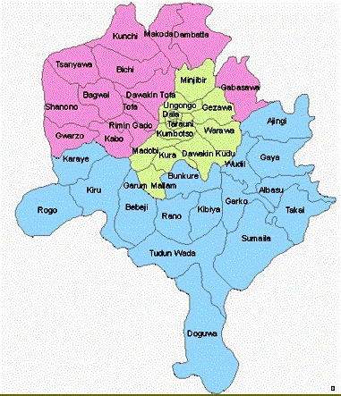

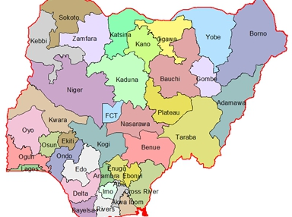

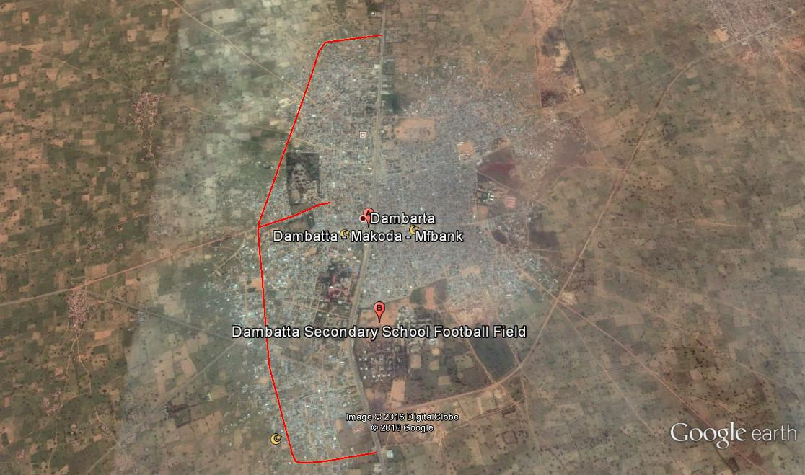

*Fig.: 1.0  Diagram Showing the Location of the Project Area*