**STREET GUIDE MAP OF BIU USING GEOSPATIAL TECHNIQUES**

**BIU TOWN , BORNO STATE.**

**A PROJECT SUBMITTED TO THE DEPARTMENT OF SURVEYING AND GEOINFORMATICS, FACULTY OF ENVIRONMENTAL SCIENCES,**

# TABLE OF CONTENT

DECLARATION PAGE ii

DEDICATION iii

APPROVAL PAGE iv

ACKNOWLEGMENTS v

ABSTRACT vi

TABLE OF CONTENT vii

LIST OF TABLE ix

LIST OF FIGURES x

CHAPTER ONE: INTRODUCTION 1

1.1 Background of the study. 1

1.2 Statement of the Problem. 3

1.3 Aim and Objectives. 3

1.3.1 Aim 3

1.3.2 Objectives. 3

1.4 Justification of the Study. 3

1.5 Scope of the Study. 4

1.6 Motives of the Study. 4

1.7 Study Area. 4

CHAPTER TWO: LITERATURE REVIEW 6

2.1 Conceptual Framework. 6

2.2 Review of Related Literature. 7

2.3 Research Gap. 11

CHAPTER THREE: METHODOLOGY 12

3.1 Preview. 12

3.2 Equipment’s used 13

3.2.1 Hardware 13

3.2.2 Software 13

3.3 Data acquisition 13

3.3.1 Reconnaissance 14

3.4 Objective i (Digitizing) 14

3.4.1 To digitize features in google earth pro. 14

3.4.2 To add digitized data from google earth pro to arc map 16

3.5 Objective ii (Map Editing) 17

3.5.1 Linking Attribute to Graphic 17

3.6 Objective iii 18

3.6.1 Coloring 18

3.6.2 Feature label 18

3.6.3 Other map element 18

3.6.4 Generation of digital Composite Map 18

CHAPTER FOUR: RESULTS AND DISCUSSION 20

4.1 Presentation of Results 20

4.2 Discussion of Results 28

CHAPTER FIVE: SUMMARY, CONCLUSION AND RECOMMEDATIONS 29

5.1 SUMMARY 29

5.2 CONCLUSION 29

5.3 RECOMMENDATIONS 30

REFERENCES 31

# LIST OF TABLE

Table 4.1 lists of attribute data

# LIST OF FIGURES

Figure 1.1 Map of the study area

Figure 3.1 Flowchart of methodology

Figure 3.2 Satellite image of Biu

Figure 3.3 Digitized image

Figure 3.4 Digitized features

Figure 3.5 Composite map of Biu

Figure 4.1 Street guide map of Biu

Figure 4.2 Show the digitized image of Biu

Figure 4.3 Show the attribute data of Major Road

Figure 4.4 Show the attribute data of Tarred Road

Figure 4.5 Show the attribute data of Untarred Road

Figure 4.6 Show the attribute data of hotels

Figure 4.7 Show the attribute data of Banks

Figure 4.8 Show the attribute data of Hospitals

Figure 4.9 Show the attribute data of educational centers

# CHAPTER ONE: INTRODUCTION

## **1.1 Background of the study.**

A map is a model of part of the earth surface showing the shape, and position of different countries, political boarders, natural features such as rivers and mountains, and artificial features such like roads and buildings (Ezra 2007). A map can also give you particular type of information about a certain area on the surface of the earth. It can be made so simple and specific that it shows direction of travel from one place to another. Reconnaissance technologies such as aerial photograph and satellite based sensing have come to man’s aid in quest to understand and preserve his environment. This advancement has given the map makers new tools for creating and updating maps as well as allowing mapping in details which is of great use most especially in planning of urban areas. Maps are specially designed to serve several purposes and answer specific questions such as street maps, utility maps etc. A street map is a type of map that contains the position and names of streets (Ezra 2007). A street map is useful in areas such as planning enumeration areas by demographers; navigation for tourists; salesmen; firemen; police; security agent; tax collectors, postal service etc. (Ezra 2007) It can also be defined as a graphic portrayal of a town or city, showing the positions and names of all the streets; major/minor highways and roads, railroads, tracks and other points of interest and the general road network.

It is a form of map that details roads and transport links (Udah 2014). A street map has the ability to provide answers to question like: where a road is where it leads to; the distance and type, the best route between two points or the shortest point (Musa 2007). Also some of the usage of street map as: for locating houses and streets; car navigation; planning of transportation, trips and driving directions; and for planning of movement and provision of facilities, goods and services (Udah 2014). Street map stands as a basic datum that can also help researchers conduct good research such as emergency response studies, proximity and accessibility studies. This can be designed and consistently updated to accommodate further developments using a robust technology such as GIS and remote sensing (Udah 2014).

Navigating through the streets of a city efficiently and accurately has always been a challenge for residents, tourists, and commuters. Traditional paper maps have long been used as a primary means of providing guidance, but they often lack the necessary level of detail and can be difficult to interpret, especially in complex urban environments. With the advancement of technology and the widespread use of digital devices, the concept of a street guide map has evolved to address these limitations and provide enhanced navigation solutions.

The development of street guide maps has been greatly influenced by the emergence of digital mapping technologies, such as Geographic Information Systems (GIS), Global Positioning System (GPS), and mobile applications. These technologies have enabled the collection, analysis, and visualization of vast amounts of spatial data, allowing for the creation of highly detailed and interactive street maps.

One of the key advantages of digital street guide maps is their ability to provide real-time information and dynamic updates. By incorporating live data on traffic conditions, road closures, public transportation schedules, and other relevant factors, these maps can offer users accurate and up-to-date navigation guidance. This real-time information allows individuals to make informed decisions about their routes, helping them avoid traffic congestion and delays.

In addition to real-time updates, digital street guide maps offer various features and functionalities that enhance the overall navigation experience. These maps can provide turn-by-turn directions, alternative route suggestions, and even voice-guided navigation, making it easier for users to navigate unfamiliar areas. Some applications also integrate additional information such as nearby points of interest, reviews, and ratings, allowing users to discover and explore their surroundings more effectively.

Moreover, the accessibility and widespread use of smartphones have made digital street guide maps highly convenient and user-friendly. Users can access these maps on their mobile devices anytime and anywhere, eliminating the need for carrying and referencing bulky paper maps. The interactive nature of digital maps enables users to zoom in, pan, and customize their views, providing a more personalized navigation experience.

To create accurate and comprehensive street guide maps, a significant amount of data collection and processing is required. This includes gathering information on street layouts, road networks, landmarks, addresses, and points of interest. Government agencies, transportation departments, and mapping companies often collaborate to collect and update this data. Additionally, crowd-sourced data from users, such as reporting road closures or suggesting new points of interest, plays a valuable role in keeping the maps current and reliable.

Overall, the background study of street guide maps highlights the evolution of navigation solutions from traditional paper maps to digital platforms. The integration of advanced technologies, real-time data, and user-friendly interfaces has significantly improved the accuracy, convenience, and effectiveness of street guide maps. By harnessing these advancements and continuously updating and refining the maps, urban navigation can become more seamless and efficient, benefiting both individuals and the overall urban environment.

In today's urban environments, street guide maps play a crucial role in assisting individuals in navigation and way-finding. These maps provide valuable information about the layout of streets, landmarks, and other spatial features, aiding both residents and visitors in finding their way around a city. Geospatial techniques, such as Geographic Information Systems (GIS), have revolutionized the creation and analysis of maps. This research focuses on the development of a street guide map for the town of Biu using geospatial techniques to enhance navigation and improve urban planning.

## **1.2 Statement of the Problem.**

Despite the growth and development of modern cities, Biu faces challenges in terms of an accurate and up-to-date street guide map. Traditional paper maps may quickly become outdated due to urban expansion, road alterations, and the dynamic nature of urban environments. There is a need for an accurate and interactive digital street guide map for Biu that can be regularly updated and easily accessible to residents and tourists.

## **1.3 Aim and Objectives.**

### **1.3.1 Aim**

The aim of this research is to create an accurate and up-to-date street guide map of Biu Town using geospatial techniques.

### **1.3.2 Objectives.**

i.To collect relevant spatial data including road networks, landmarks, and points of interest, within the study area.

ii.To employ geospatial techniques to analyze and process the collected data.

iii.To produce a digital street guide map of the study area.

## **1.4 Justification of the Study.**

The development of an accurate street guide map for Biu using geospatial techniques is essential for several reasons. It will enhance urban planning by providing reliable data for decision-making and infrastructure development. Additionally, it will improve navigation for residents and tourists, thereby boosting local tourism and economic growth. This study contributes to the broader field of geospatial technology and urban planning by showcasing the practical application of GIS in addressing real-world challenges.

## **1.5 Scope of the Study.**

This research focuses specifically on the creation of a street guide map for the town of Biu. It includes the collection, analysis, and visualization of spatial data related to road networks, landmarks, and points of interest. The study does not encompass broader urban planning initiatives beyond the development of the street guide map.

## **1.6 Motives of the Study.**

The motivation behind this research flow from the need to bridge the gap between outdated paper maps and modern digital navigation tools. By leveraging geospatial techniques, the study aims to provide an innovative solution to enhance navigation, urban planning, and overall quality of life for Biu's residents and visitors.

## **1.7 Study Area.**

The study area is Biu, a town located in northeastern Nigeria. Biu serves as a commercial and administrative center within the Borno State. It is characterized by a growing population, evolving road networks, and the presence of various landmarks. The town's unique urban dynamics and developmental needs make it an ideal location for the implementation of an advanced street guide map using geospatial technique.

Biu Metropolis is located in Biu Local Government Area, Borno State, Nigeria. It is situated approximately 180 kilometers south-east of Maiduguri, the state capital. Biu town lies within the geographical coordinates of approximately 10°37'N latitude and 12°11'E longitude. The town is accessible via major road networks and is strategically located along the routes connecting various towns and cities in the region.

The geographical location of Biu Metropolis in Borno State positions it as an important centre for trade, transportation, and regional connectivity. Its location close to the Mandara Mountains and the Cameroon border adds to its significance strategic.

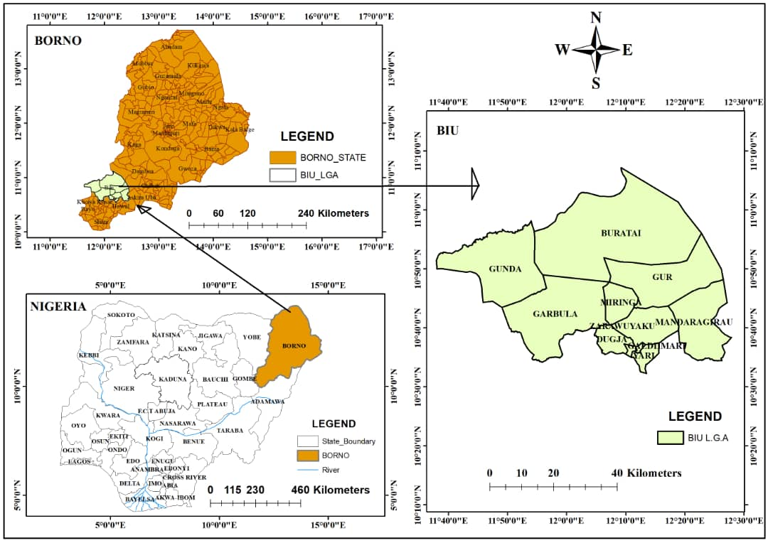

Figure 1.1 Map of the Study Area.