# THIRD ORDER CONTROL EXTENSION WITHIN THE NIGERIAN ARMY UNIVERSITY BIU (NAUB) BORNO STATE, NIGERIA

**A PROJECT SUBMITTED TO THE DEPARTMENT OF SURVEYING AND GEOINFORMATICS, FACULTY OF ENVIRONMENTAL SCIENCES**

# ABSTRACT

*This project is a third order control extension at the Nigerian Army University Biu in Biu Local Government Area of Borno State. The project was executed using ground survey method and techniques with the aid of differential GPS (DGPS). Geometric data were acquired through: static mode and real-time kinematic mode. The acquired geometric data were deduced, processed and adjusted using appropriate computational formulae based on the third order specification. The project was analyzed and confirmed to fall within allowable misclosure and the linear misclosure was 1:10000. Also, after the confirmation of the point to be established, 13 sets of control framework were extended over a perimeter length of 2.9km and the final adjusted coordinates were used to produce a digital plan showing the third order control framework of the study area using a scale of 1:5000.* *Finally, the project report was written on each step involved.* *The aim of the project was achieved (i.e. third order controls extension at Nigerian Army University Biu.) and shall contribute greatly to the area as a whole since it lacked controls for ease of survey jobs. Therefore, it is recommended that there should be public enlightenment on the need and importance of geodetic controls and also, control stations should be situated at points in which they are exposed to threats as a result of physical developments.*

# TABLES OF CONTENTS

COVER PAGE i

TITTLE PAGE ii

DECLARATION iii

DEDICATION iv

APPROVAL v

ACKNOWLEDGEMENTS vi

ABSTRACT vii

TABLES OF CONTENTS viii

LIST OF TABLES xi

LIST OF FIGURES xii

LIST OF APPENDICES xiii

CHAPTER ONE 1

INTRODUCTION 1

1.1 Background 1

1.2 Statement of Problem 3

1.3 Aim and Objectives 3

1.3.1 Aim 3

1.3.2 Objectives 3

1.4 justification of the Study 3

1.5 Scope of the study 4

1.6 Study Area 4

CHAPTER TWO 6

2.1.0 CONCEPTUAL FRAMEWORK 6

2.1.5 Guidelines for Conducting GPS Project 9

2.1.9 GPS Observations Guidelines 12

2.1.10 Observational requirements for static baselines 12

2.1.11 Observational requirements for fast static baselines 13

2.1.12 GPS Network Schemes 13

2.1.13 Networking method (Pivot method) 13

2.1.14 Traversing method 14

2.2.0 REVIEW OF RELATED LITERATURE 16

2.2.4. Traverse Technique for Establishing Geodetic Controls 29

2.2.5 Triangulation Technique for Establishing Geodetic Controls 30

2.2.6 Triangulateration Technique of Establishing Geodetic Controls 32

2.2.8 Sources of GPS Errors 34

2.2.9 Effect of GNSS Observation Time on Post processing 35

2.2.10 Project Specification According to SURCON 36

2.3 Research gap 36

CHAPTER THREE 38

METHODOLOGY 38

3.1 Preview 38

3.2 Equipment used 39

3.2.1 Hardware 39

3.2.2 Software 39

3.2 Materials and Methods 39

3.3 Reconnaissance 39

3.3.2 Field Reconnaissance 40

3.4 Monumentation of Selected Stations 41

Survey beacon cast in-situ for the project 41

3.5 Field Observation 41

3.5.1 DGPS Configuration (Hi-target V90) 42

3.5.2 Working Principle of the GPS 42

3.5.3 Test of Instrument 42

3.5.4 Control Check 43

3.6 Procedure for GPS Observation 44

3.7 Precautions Taken During Observation 45

CHAPTER FOUR 46

RESULT AND DISCUSSION 46

4.0 Data Download and Processing 46

4.1 Result Presentation 48

4.2 Discussion of result 48

4.3 validation of controls 48

4.4 Graphical Presentations 49

4.5 AutoCAD plotting procedure 49

4.6 Application of result 50

CHAPTER FIVE 51

SUMMARY, CONCLUSION AND RECOMMENDATION 51

5.1 Summary 51

5.2 Problems Encountered 51

5.3 Conclusion 51

5.4 Recommendation 51

REFERENCES 53

# LIST OF TABLES

Table 3.2: Analysis and comparison between observed and existing (given details) …………43

Table 4.1: Result ofadjusted coordinates of control points………………………………….48

Table 4.2: Result of Coordinates data obtained by DGPS in real time kinematic mode…….49

# LIST OF FIGURES

Figure 1**:** Map of the study area………………………………………………………………...5

Figure 2.1: NIGNET and Nigerian Primary Geodetic Network (GPS Monuments)………...26

Figure 3.1 Flowchart of methodology………………………………………………………..38

Figure 3.2 Typical control beacon……………………………………………………………41

# LIST OF APPENDICES

APPENDIX I Digital plan

APPENDIX II Pillar Description

APPENDIX III Recce diagram

# CHAPTER ONE

## INTRODUCTION

## Background

The history of surveying dates back to ancient times, with a recorded land registered in Egypt in 3000BC, and re-establishment of farm boundaries following floods of the Nile River and construction of the Great Pyramid of Giza recorded about the same time. The survey practices were geared towards economic exploration and exploitations. In Nigeria survey practices were in the areas of cadastral surveys, were essentially for the acquisition of land for the crown and developments of estates, mineral resources, road and rail designs, and survey control establishments.

According to Kufoniyi (2013), he defined surveying as the science and technology of taking measurements on, above and/or under the surface of the Earth and the representation of same on plan or map using appropriate scale. However, because of the availability of modern Geo-ICT tools and space technology, and to emphasize the need for a service-oriented professional practice, Kufoniyi while quoting NIS, 1997, defined a surveyor as “a *professional person with the academic qualification and technical expertise to practice the science of measurement, to assemble, assess land and geographic related information, to use that information for the purpose of planning and implementing the efficient administration of the advancement and development of such practices”.*

For surveying to operate effectively, there is need to have reference framework that will be used for orientation. Control station is a small mark set immovably into the ground, such that an instrument (e.g. a total station or GPS receiver) or optical target can be set up above it, to an accuracy of about 1 mm in the horizontal plane (Aylmer, 2004).

Control maybe classified as an established precise position of reference monument to serve as the basis for originating or checking the result of some other working methods (C.D Ghilani & P.R Wolf, 2008). No meaningful development can succeed without adequate surveys. Also, no registration of title over a landed property can be effective if cadastral surveys are not tied to controls. Such reliable controls are at present not available within the Nigerian Army University Biu. Hence this project was initiated by me. This project is therefore, aimed at providing such needed control points (3rd Order) in this area. The establishment of this Controls will be very useful to the department of Surveying and Geoinformatics and other practicing surveyors who might need them for various survey activities.

Control densification is an important concept of surveying, because every survey practiced either in large or small area requires a set of control framework to fit into, i.e. vertical and horizontal controls. The vertical controls deal with determination of the height of points, the process employed is known as leveling. In achieving the elevation of a point above a given datum, classical methods employed are Bathymetric, trigonometric, reciprocal and spirit leveling. But recently we can use total station and Global Positioning System (GPS), for height determination.

In the determination of the horizontal control framework, this can be established using various conventional methods like triangulation, trilateration, and traversing. These methods are used to determine the coordinates of point i.e., the position of the point. However, due to the time spent in the production of network of control and the huge amount expended on the course of creating this framework using the conventional method, therefore lead to the rise of modern surveying instruments and techniques, so we have the advent of GPS in surveying which is a satellite-based radio navigation system.

Control point which can also be referred to as reference point could be temporal or permanent. These reference points are located apart depending on the topography and inter-visibility to each other; establishment of these reference points require high accuracy since further survey works shall be tied to them.

Controls differ in accuracy; their accuracy gives the order in which they fall and that determines their uses also. Control surveys are established to generate a network of controls in which lower order of controls are tied to higher order of controls. The higher order of control is more accurately and precisely monumented. Control survey is performed in a manner in which very high accuracy is achieved with regards to horizontal coordinates and heights of the points.

Controls are considered to be base which determined the accuracy of position fixing for both horizontal and vertical position and is for enormous relevance to engineering projects such as mapping, fixing of shafts and tunnel alignments in mining, monitoring of structural deformation and movement etc.

Onwiziligbo (2008) emphasized on the importance of geodetic controls. He further advised that all geodetic controls should be connected or tied to already existing to enhance their accuracy.

Satellite innovations has advanced and is widely applied in geodesy through the utilization of GPS and this has strengthened and enhanced the accuracy of geodetic control networks around the world. This network of controls was designed to conform to 3rd Order standard.

## 1.2 Statement of Problem

The need for third order control in the study area is due to inadequate availability of geodetic control network within the region which will aid the orientation, alignment and can also serves as the reference frame work for all surveys, constructions and engineering projects. Hence, it is essential that controls are established since the area is still under development stage and need controls for proper engineering works.

## 1.3 Aim and Objectives

## 1.3.1 Aim

The aim of the project is to establish third order controls in the Nigerian Army University Biu (NAUB) using Differential GPS (DGPS) technology so that other subsequent survey job can be connected.

## 1.3.2 Objectives

The objectives of the project are as follows:

1. To ascertain where is suitable for the siting and monumentation of the proposed control.
2. To monument and carry out effective GPS observation according to SURCON.
3. To carry out post-processing of the obtained data, present and analyze the corrected final result as well as present a plan shewing the controls extension.

## 1.4 justification of the Study

The findings of this study will contribute to the body of knowledge on surveying and mapping techniques, specifically in the context of establishing third order controls in Nigerian Army University Biu (NAUB). By exploring the utilization of DGPS technology, this research will provide insights into the potential benefits and challenges associated with its implementation. The study's recommendations can guide NAUB in improving their surveying and mapping capabilities, enhancing operational efficiency, and supporting infrastructure planning and disaster management.

## 1.5 Scope of the study

This research focuses on the extension of third order controls using DGPS technology in NAUB. It includes the following:

1. Reconnaissance
2. Selection of stations
3. Monumentation
4. Test of instrument
5. Control check
6. Pillar description
7. Geometric data acquisition
8. Data download
9. Presentation of result.
10. Project report writing.

## 1.6 Study Area

The study area is the Nigerian Army University Biu (NAUB), located in Biu, Borno State, Nigeria. Biu is a town situated in the southern part of Borno State, with geographical coordinates approximately 10°36’39.96’’N latitude and 12°11’42.00’’E longitude respectively.

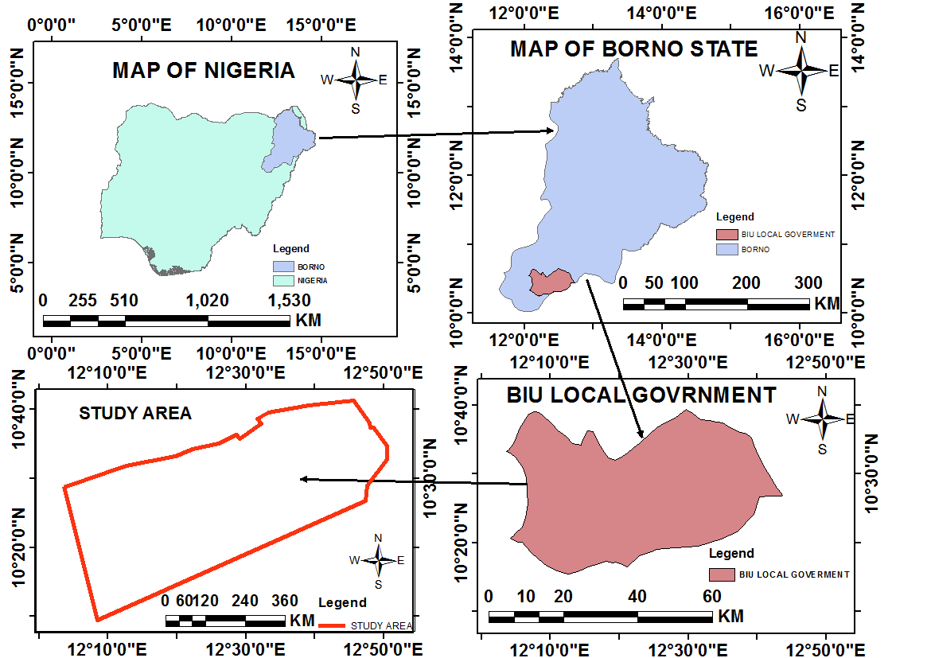

**Figure 1.6:** Map of the study area

**Source:** Modified after Administration Map of Borno State (2022).